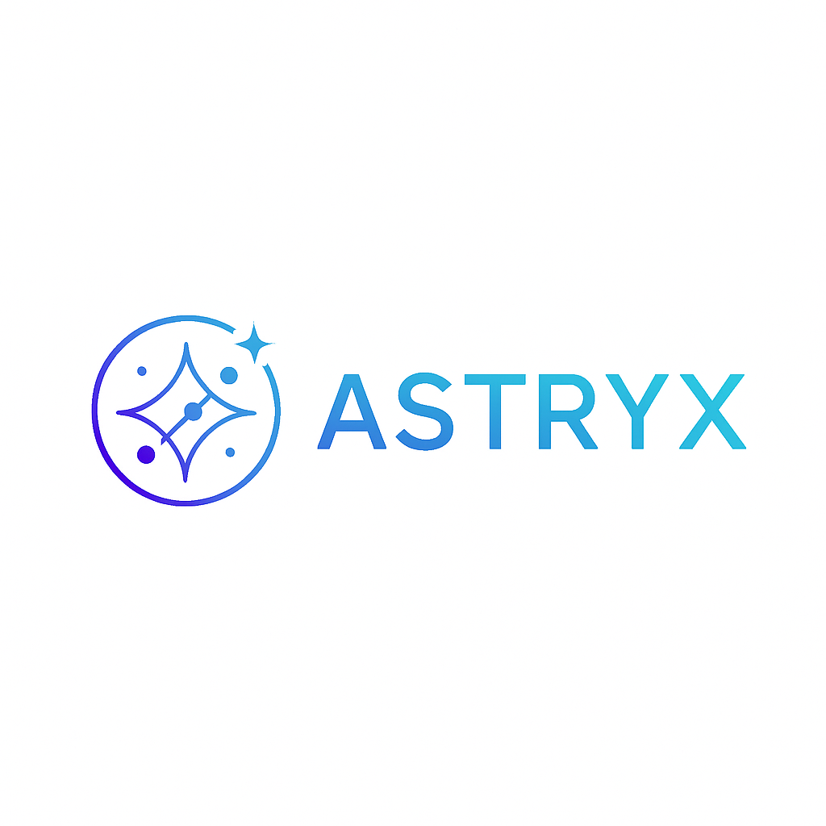

**Astryx:**

**Next Generation layer1 Blockchain Technology**

**white paper**

**Table Of Contents**

1. Introduction to Astryx and Existing Concepts
2. History
3. Astryx as a State Transition System
4. Mining / Validation
5. Merkle Trees and Data Structures
6. Alternative Blockchain Applications
7. Scripting and Smart Contracts
8. Astryx Platform Overview

* Astryx Accounts
* Messages and Transactions

1. Astryx State Transition Function
2. Code Execution
3. Blockchain and Mining
4. Applications

* Token Systems
* Financial Derivatives and Stable-Value Currencies
* Identity and Reputation Systems
* Decentralized File Storage
* Decentralized Autonomous Organizations (DAOs)
* Further Applications

1. Miscellaneous and Concerns

* Security, Privacy, and Compliance
* Modified GHOST Implementation (if relevant)
* Fees
* Computation and Turing-Completeness
* Currency and Issuance
* Long-Term Supply Growth Rate
* Mining/Validation Centralization
* Scalability

1. Conclusion
2. Notes and Further Reading
3. References
4. **Introduction to Astryx and Existing Concepts**

**Astryx’s Mission: Why a New Layer 1?**

Astryx is conceived as a transformative blockchain platform built to power the next wave of decentralized innovation, targeting both developer empowerment and frictionless user experiences. The mission is to overcome limitations that have plagued existing Layer 1 blockchains and drive mass adoption for scalable, secure, and versatile applications in finance, gaming, artificial intelligence, and beyond.

Existing Layer 1 chains like Ethereum and Solana laid the foundations for decentralized economies, but as blockchain adoption grows, their architectural choices reveal persistent bottlenecks. Astryx is designed not as a minor upgrade but as a holistic reimagining prioritizing throughput, interoperability, flexible smart contracts, and adaptive governance. With Astryx, the goal is to create an ecosystem where the boundaries between chains, assets, and users dissolve, making blockchain tech as seamless as the internet.

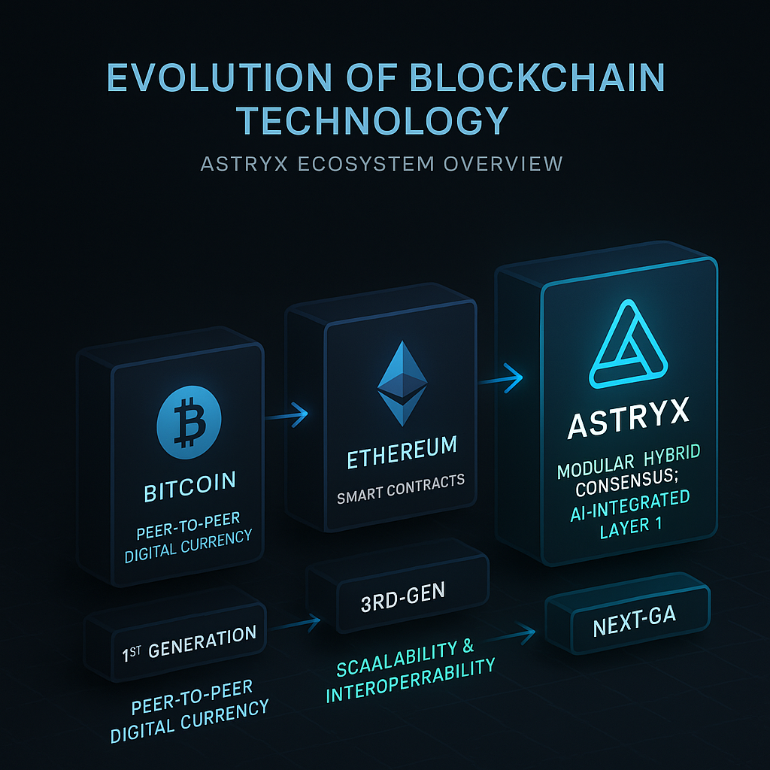

Our vision is clear: unlock mainstream adoption by making decentralized technologies genuinely scalable, developer-friendly, cross-compatible, and futureproof for new fields (such as AI-powered dApps). Astryx aims to be the backbone for digital economies of the future, where finance, gaming, and intelligent applications are natively decentralized, secure, and open to all.

**Blockchain Technology Evolution: Limitations of Predecessors**

**First Generation (Bitcoin)**

Bitcoin pioneered peer-to-peer money and digital scarcity, introducing the world to blockchain’s ability to record immutable, consensus-driven transactions. Its design was intentionally simple a “state transition system” for sending and receiving coins but this rigidity made programmability and high-speed execution impossible. Bitcoin’s throughput remains low (roughly 7 transactions per second), and energy-intensive proof-of-work consensus hinders sustainable scaling.

**Second Generation (Ethereum)**

Ethereum’s major leap was a Turing-complete smart contract platform. Anyone could deploy decentralized applications (dApps), enabling DeFi, NFTs, DAOs, and more. But Ethereum’s architecture single-chain execution, complex tooling (Solidity, EVM), and proof-of-work (before its 2022 transition to proof-of-stake) restricted both transaction speed (15-30 TPS) and affordability (often >$10 per txn during peak periods). Scaling upgrades like sharding and rollups remain incomplete, and network congestion continues to affect user experience.

**Third Generation and Beyond (Solana, Avalanche, Sui, Aptos)**

Solana and its peers embraced parallel execution, alternative programming languages, and faster consensus models (such as proof-of-history and delegated proof-of-stake). These advances increased throughput (Solana can reach tens of thousands of TPS), but often at the expense of decentralization and robustness Solana, for example, has experienced several outages due to its unique design constraints and limited validator diversity.

Other chains like **Avalanche** introduced modularity (customizable subnets) and improved finality, while Aptos and Sui built on the Move language for better safety and developer ergonomics. Still, challenges persist: limited interoperability between chains, fragmented developer tools, centralized governance risks, and insufficient infrastructure for emerging demands like AI or high-frequency gaming.

**Core Design Gaps**

* Scalability: Most Layer 1s still struggle to support real-time, mass-market applications without sacrificing decentralization.
* Interoperability: Assets and data in one ecosystem remain siloed, hindering seamless cross-chain user experiences and limiting liquidity.
* Developer Experience: Custom languages, poor documentation, and slow onboarding deter new builders.
* Governance: Centralized decision-making can stifle growth and alienate the community.
* Specialization: No general-purpose Layer 1 currently offers native support for AI computation, cross-chain gaming economies, or enterprise-grade compliance.

**Overview of Astryx Target Use Cases**

* **Scalability**

Astryx’s sharded, parallelized architecture is engineered to process tens of thousands of transactions per second and achieve sub-second finality, making high-throughput dApps viable for millions of users. The platform is specifically optimized for low-latency interactions critical in gaming and financial transactions.

* **Interoperability**

Seamless interoperability is core to Astryx. Through native cross-chain message passing, decentralized bridges, and programmable asset standards, Astryx enables users and developers to transact across public and private chains without friction. This unlocks truly global liquidity and cross-ecosystem composability.

* **Artificial Intelligence Integration**

Astryx anticipates the rise of AI and autonomous agents within the blockchain. Its virtual machine incorporates secure, resource-efficient execution environments designed for AI-centric smart contracts, allowing developers to build predictive analytics, autonomous trading bots, and intelligent dApps natively on-chain.

* **Decentralized Finance (DeFi)**

DeFi remains a key use case. Astryx supports robust protocols for lending, trading, synthetic assets, derivatives, and stablecoins benefiting from sub-second settlement and negligible fees. Compliance-ready identity and reputation systems foster safer, more transparent financial marketplaces.

* **Gaming**

Gaming on blockchain today is bottlenecked by speed, throughput, and user experience. Astryx’s architecture supports real-time, on-chain gameplay, resilient NFT economies, and developer-friendly SDKs for game studios. With high TPS and low latency, game logic, asset trading, and social features can be fully decentralized without compromise.

**Why Astryx Matters Now**

The need for a new Layer 1 is driven by concrete limitations of today’s blockchains as well as the emerging demands of Web3. Astryx is born from a pragmatic assessment of what decentralized applications require for scale and usability combining innovation in consensus, scalability, interoperability, and developer experience. In focusing on the pressing needs of DeFi, gaming, and intelligent dApps, Astryx stands to unlock new economic opportunities, empower builders, and offer a truly borderless digital platform for tomorrow’s enterprises and communities.

Astryx is not just another Layer 1. It is a foundation for the next era of decentralized innovation where speed, scale, openness, and intelligence converge.

1. **History**

**The Evolution of Blockchain Technology**

Blockchain technology emerged from the need to create trustless, decentralized digital systems that could operate without centralized authority. The concept was first introduced by the anonymous figure Satoshi Nakamoto in the 2008 Bitcoin white paper, which outlined a peer-to-peer digital currency that leveraged cryptographic proofs rather than trust in intermediaries. Bitcoin’s launch in 2009 marked the inception of the first blockchain a distributed ledger recording sequential blocks of transactions, each cryptographically chained to its predecessor.

Bitcoin’s innovation lay in solving the “double-spending problem,” ensuring that digital assets could not be spent twice. Its consensus mechanism, Proof-of-Work (PoW), incentivized participants (miners) to validate transactions and secure the network. While revolutionary, Bitcoin’s scope was intentionally narrow, focusing solely on payments and simple transactions.

The next significant leap was Ethereum, conceived by Vitalik Buterin and launched in 2015. Ethereum expanded blockchain’s capabilities by introducing a generalized platform for “smart contracts” self-executing programs that could run on the distributed ledger. Ethereum transformed blockchain from a value-transfer system into a decentralized world computer, spawning entire industries such as decentralized finance (DeFi), non-fungible tokens (NFTs), and complex DAOs (Decentralized Autonomous Organizations). Other projects soon followed, including EOS, Tezos, and NEO, each offering distinctive features in governance, scalability, or developer sophistication.

**Layer 1 Platforms: Foundation for Decentralization**

Layer 1 blockchains are the base protocols that underpin decentralized applications and networks. They provide the foundational security, consensus, and programmability for the entire ecosystem. Bitcoin and Ethereum are textbook examples, but a proliferation of Layer 1s emerged in subsequent years:

* **Solana:** Introduced parallel transaction processing for high throughput.
* **Avalanche:** Leveraged a novel consensus protocol for low latency and subnets for modular customizability.
* **Aptos and Sui:** Used Move language and advanced execution models targeting developer efficiency and scalability.

Each new Layer 1 sought to address the perceived weaknesses of its predecessors, striving for faster transactions, lower costs, better developer experiences, or more inclusive governance.

**Major Shortcomings of Early Layer 1 Platforms**

Despite blockchain’s transformative potential, foundational Layer 1 protocols struggled with several key limitations:

**1. Throughput**

Most legacy Layer 1 chains are not natively built for mass adoption. Bitcoin’s maximum throughput sits at about 7 transactions per second (TPS); Ethereum originally managed 15-30 TPS. These rates pale compared to centralized networks like Visa, which can process thousands of TPS. As protocol usage exploded especially during bull markets networks became congested, with transactions delayed or dropped.

**2. Speed**

Slow block times and the need for multiple confirmations undermine user experience, especially for real-time applications like gaming or trading. Ethereum transactions often took 12-15 seconds or more to finalize, while Bitcoin could take minutes. Efforts to optimize speed, such as Solana’s parallel runtime, introduced other trade-offs in network stability and complexity.

**3. Cost**

Scarce blockspace and congestion lead to high transaction fees. On Ethereum, “gas wars” during periods of high demand have led to fees soaring to $50 or more per transaction. This cost structure excludes casual users, stifles experimentation, and elevates the barrier to entry for new applications.

**4. Developer Experience**

Developer onboarding to blockchains like Ethereum is hampered by complex languages (e.g., Solidity), steep learning curves, and unintuitive debugging environments. Smart contract errors can be catastrophic bugs and hacks have drained billions from DeFi protocols. Documentation, tooling, and community support have improved over time, but early Layer 1s emphasized security over usability, slowing broader adoption and innovation.

**5. Governance**

Blockchain governance the processes by which protocols upgrade or make decisions is a double-edged sword. Bitcoin’s development is conservative, requiring deep consensus and often resisting change to maintain security. Ethereum introduced the Ethereum Improvement Proposal (EIP) process, but contentious upgrades (e.g., The DAO hard fork, the merge to Proof-of-Stake) exposed risks of slow responses and community fractures.

Centralized governance (where few actors hold outsized influence) can alienate users and developers, while purely decentralized approaches can paralyze decision-making. Striking this balance is an ongoing challenge.

**The Push for Next-Generation Platforms**

Recognizing these shortcomings, modern Layer 1s attempt to redesign fundamental aspects:

* **Scalability solutions:** Sharding, sidechains, and rollups allow for parallel processing and horizontal growth.
* **Consensus Innovations:** Hybrid PoS, delegated proof-of-stake, or novel BFT algorithms improve speed and efficiency.
* **Developer Tooling:** Languages like Rust or Move (used by Solana, Aptos, Sui) focus on safety and productivity.
* **Governance Flexibility:** Protocols now embed mechanisms for more adaptive upgrades, greater community voice, and transparent decision-making.

Still, perfection remains elusive. The trade-off between scalability, decentralization, and security known as the “blockchain trilemma” is at the core of ongoing research. The ideal Layer 1 remains one that can enable billions of users, support diverse applications, and adapt gracefully to technological and social change.

1. **Astryx as a State Transition System**

**What Sets Astryx’s Architecture Apart from Prior Models?**

Astryx is envisioned as a next-generation Layer 1 blockchain platform, purpose-built to address the core deficiencies of legacy chains like Ethereum, Solana, and Avalanche. The design philosophy behind Astryx is rooted in creating a seamless balance between scalability, security, and developer experience, leveraging lessons from previous blockchains while introducing architectural innovations that propel mass adoption, especially in high-throughput, real-time applications like gaming, DeFi, and AI-driven dApps.

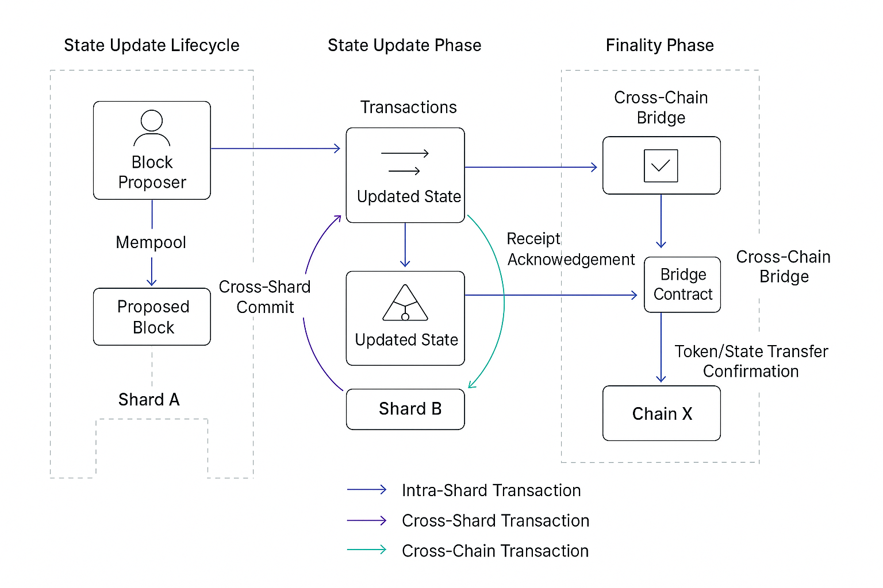

The fundamental breakthrough of Astryx lies in its modular, adaptive state transition system that combines advanced sharding, parallel execution, and AI-assisted smart contract management. While traditional blockchains maintain a single chain of blocks, Astryx divides state and transaction processing across shards smaller, manageable sub-chains that operate semi-independently while preserving global consensus through an optimized BFT (Byzantine Fault Tolerant) protocol layered atop Proof-of-Stake (PoS). This approach allows Astryx to support thousands of concurrent transactions with sub-second finality far surpassing the 15-30 TPS of Ethereum and matching or exceeding the throughput of Solana, but with enhanced resilience and decentralization.

Moreover, Astryx is designed to be natively interoperable and developer-friendly. The platform supports smart contracts in multiple languages (including Rust, Move, and its own Astryx VM), making onboarding easier for Web2 and blockchain programmers alike. This stands in stark contrast to Ethereum’s Solidity-first, EVM-centric approach, which, while powerful, has a steep learning curve. Astryx’s SDK abstracts away many complexities, offering intuitive APIs, real-time debugging, and built-in compliance modules.

**Technical Overview: State, Transactions, and Evolution**

**1. State Architecture**

At the heart of Astryx’s innovation is its partitioned state model. Global blockchain state in Astryx is split into “state shards” each responsible for a specific subset of accounts, smart contracts, and data. Rather than every validator maintaining and processing the entire state as in Ethereum, each validator in Astryx is assigned to a shard, dramatically increasing parallelism and network scalability.

State Root: Each shard keeps its own Merkle tree of states (balances, smart contract storage, etc.), summarized by a shard-specific state root.

Global Integrity: The set of all shard roots forms Astryx’s global state root. Periodically, these roots are synchronized, ensuring consistent ordering and conflict resolution for cross-shard transactions.

This design allows Astryx to horizontally scale as demand grows, avoiding bottlenecks and limiting the risks of downtime due to congestion or node failures.

**2. Transactions**

Astryx supports several types of transactions:

* **Shard-local:** Transfers and contract calls within a shard are processed instantly, benefitting from high throughput due to parallelization.
* **Cross-shard:** When transactions span multiple shards (e.g., transferring assets to another shard), Astryx employs asynchronous message passing and a two-phase commit protocol. Cross-shard operations are orchestrated by a global coordinator an efficient, decentralized logic layer that ensures atomic execution and state consistency.
* **Interchain:** Astryx includes native interoperability bridges, enabling seamless asset movement and contract calls to/from external chains using standardized protocols and cryptographic proofs (e.g., zero-knowledge proofs for privacy-preserving extensions).
* **Smart Contract Calls:** Unlike Ethereum’s gas-driven metering, Astryx introduces adaptive resource allotment. Developers can predefine maximum computational budgets for contract execution, with fees adjusted based on real-time network conditions, keeping costs predictable.

**3. Consensus and State Evolution**

Astryx advances the consensus paradigm by combining PoS with modular Byzantine Fault Tolerance validators are dynamically assigned to shards for a given epoch based on stake, reputation scores, and randomization (using verifiable random functions, VRFs).

* **Block Production:** Within each shard, block proposers validate transactions, update local state, and generate Merkle proofs of correctness.
* **Global Finality:** Once the majority of shard blocks reach local consensus, the global coordinator aggregates shard roots and publishes a super-block, updating the unified global state root.
* **Fork Resolution:** Forks are resolved via a modified GHOST protocol, which extends the longest-chain rule to consider cross-shard dependencies and validator reputations, making Astryx more resilient to network splits and attack vectors.

**4. Security and Adaptivity**

Astryx goes beyond static security assumptions:

* State sharding inherently limits the attack surface, since compromising a shard does not threaten global state integrity cross-shard proof coordination is required for any changes.
* Adaptive Smart Contracts: Astryx smart contracts can self-adjust resource allocation and even network fee preferences based on traffic and historical execution, helping prevent congestion and denial-of-service attacks.

**5. Developer Experience and Upgradability**

* Flexible Scripting: The Astryx VM is language-agnostic, supporting plug-in execution environments. Developers choose Rust for performance, Move for safety, or a domain-specific language for AI-centric logic.
* Instant Debugging and Version Control: With integrated state diffing and rollback, developers can deploy, test, and iteratively improve smart contracts without risking mainnet stability a sharp contrast to the rigidity of current Layer 1s.

**6. Evolution and Governance**

Astryx’s upgrade process is modeled on decentralized governance. Protocol upgrades, shard resharding (dynamic partitioning based on load), and feature enhancements are proposed and voted on by the community using on-chain governance modules, backed by staked tokens and reputation scores, minimizing the fragmentation and risks of contentious forks.

1. **Mining / Validation**

**Mining and Validation in Astryx: Consensus, Participation, and Decentralization Strategies**

**1. Overview: Astryx’s Consensus Mechanism**

Astryx is built as a next-generation Layer 1 blockchain platform with a relentless focus on high throughput, robust security, and credible decentralization. At its core, Astryx leverages a hybrid consensus mechanism that blends Proof-of-Stake (PoS), Byzantine Fault Tolerance (BFT), and state sharding. This multifaceted approach seeks to overcome the shortcomings of previous blockchains namely limited scalability, energy inefficiency, and centralization risks while laying the technical foundation for real-world applications across DeFi, gaming, AI, and enterprise integrations.

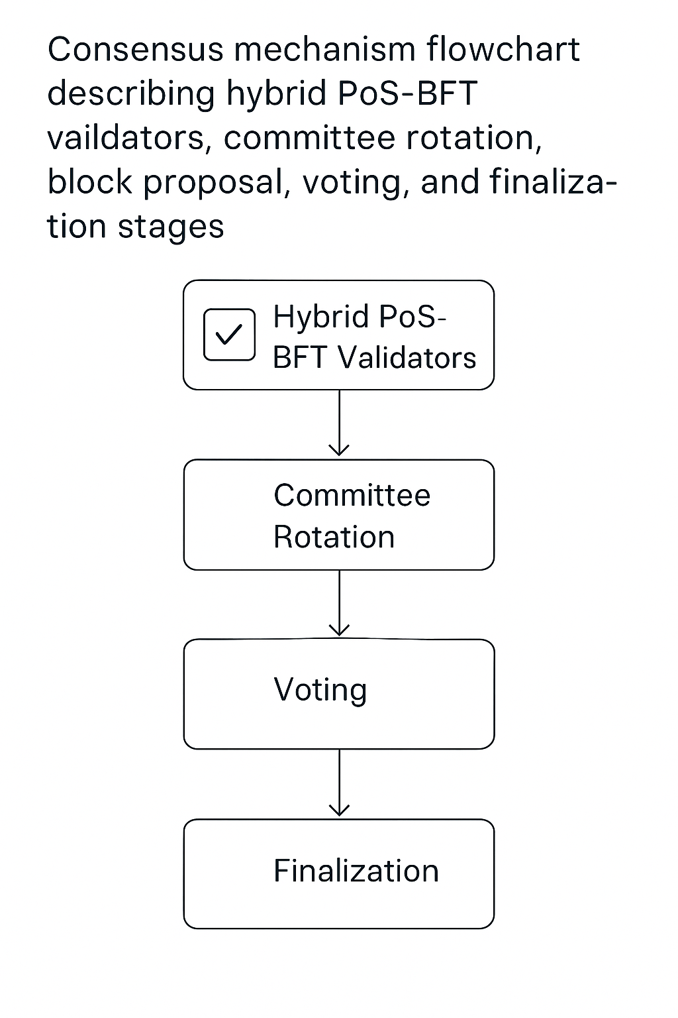

**A. Hybrid PoS-BFT Foundation**

Proof-of-Stake (PoS): Astryx replaces energy-intensive mining with PoS, where validators are chosen to propose and attest to new blocks based on their token stake. This drastically reduces energy consumption and promotes stakeholder alignment. Validators lock up a portion of Astryx’s native token to signal their commitment to network security.

**Byzantine Fault Tolerance (BFT):** To optimize for speed and security, PoS is interwoven with BFT finality. In practice, a rotating set of validators form committees for each shard and block epoch. These committees run a BFT protocol (inspired by Tendermint or HotStuff), which swiftly decides on block validity even in the presence of malicious actors. Through multi-phase voting and digital signatures, fast block finality (sub-second under ideal conditions) is achieved, preventing forks and double-spends.

**State Sharding:** The blockchain’s state is partitioned into independent shards. Each shard processes transactions in parallel, multiplying throughput, while cross-shard communication protocols maintain atomicity and composability. Each shard’s committee is selected randomly and periodically reshuffled for safety and fairness.

**2. Validator Participation:** Roles, Incentives, and Security

The Astryx network sustains its decentralization and integrity through active validator engagement and robust participation incentives.

**A. Becoming a Validator**

Staking Requirement: Prospective validators must lock a significant amount of Astryx tokens, which serves as collateral to protect against slashing (penalties for malicious or negligent behavior).

**Onboarding Process:** Validators undergo registration, including hardware checks, onboarding tutorials, and identity verification (optional, for enterprise shards). Upon approval, they join the pool for random committee selection.

**B. Block Proposal and Voting**

**Committee Assignment:** For each block or epoch, validators are randomly assigned to specific shards and committees. This randomness, drawn from decentralized VRFs (Verifiable Random Functions), mitigates collusion and targeted attacks.

**Proposal:** Within a shard, a designated validator proposes the next block, gathering transactions and state updates.

**BFT Voting:** Other committee members validate the block’s correctness (transaction validity, signature integrity, state transition logic) and participate in multi-round BFT voting. Blocks passed by a supermajority (>2/3) are finalized and added to the chain.

**C. Rewards and Penalties**

**Staking Rewards:** Validators earn block rewards and transaction fees proportional to their contributed stake and performance. A dynamic APY model is employed higher network demand yields more generous rewards, balancing supply and inflation.

**Slashing and Penalties:** Validators engaging in double-signing, censorship, downtime, or collusion face automatic slashing of staked tokens. This is enforced by light clients and cryptographic fraud proofs, instantly cutting out bad actors.

**D. Validator Diversity**

**Incentive Diversity:** Astryx’s staking protocol is open to small and large stakeholders alike. Pooled staking and delegation schemes allow token holders to participate via staking pools, diversifying committee make-up.

**Geographic and Jurisdictional Spread:** Astryx encourages validators from various regions to prevent jurisdictional risks; incentives and targeted grants help bootstrap underrepresented geographies.

**3. Securing the Network: Mechanisms and Defense Layers**

Astryx’s validator framework integrates multiple mechanisms to ensure operational security against external and internal threats.

**A. Randomized Committee Selection**

By regularly reshuffling validator assignments to shards and epochs, Astryx limits the time window for adversaries to coordinate attacks; this ephemeral committee model enhances both security and censorship resistance.

**B. Multi-Layered Consensus**

Shards run BFT for internal transaction validation, while a global finalization protocol periodically checkpoints all shards’ latest states. This dual process preserves overall consistency and atomic execution across the fragmented network.

**C. Fraud and Light Client Proofs**

Astryx employs fraud proofs and cryptographic proofs verifiable by lightweight clients, enabling anyone to audit and challenge malicious block proposals an essential guardrail against collusion or systematic abuse.

**D. Infrastructure Security**

Validators are required to run redundant setups, including backup nodes, cold/warm failover configurations, and encrypted HSM (Hardware Security Module) key management. Optional compliance modules offer enterprise-grade monitoring.

**E. Governance Integration**

Validator governance upgrades, parameter adjustments, and economic policy changes occurs on-chain, with each validator’s vote weighted by staked tokens. This keeps technical progress transparent and responsive, while avoiding centralization.

**4. Energy Efficiency and Decentralization Strategies**

**Energy efficiency and decentralization are the pillars of Astryx’s design philosophy.**

**A. Eliminating Proof-of-Work**

By shifting from PoW to PoS, Astryx avoids the massive energy draw associated with mining hardware. Network operation is reduced to simple cryptographic calculations and message passing, allowing nodes to operate on commodity servers or renewable-powered infrastructure.

**B. Validator Resource Optimization**

Validators are incentivized to use renewable sources and carbon-neutral data centers; periodic audits reward eco-friendly operations with “green staking” bonuses. Astryx’s protocol deliberately minimizes required computational and bandwidth overhead.

**C. Lightweight Node Support**

Astryx’s architecture incorporates light clients, enabling environmental and resource savings for users and small stakeholders, furthering decentralization.

**D. Preventing Centralization**

* **Open Staking Pools:** Delegation enables anyone with tokens to participate, not just those with powerful hardware or large holdings.
* **Slashing Protocols:** Heavy slashing penalties and transparent fraud-proof reporting discourage centralization through collusion or cartel formation.
* **Periodic Rotation:** Constant reshuffling of committee assignments and randomized leader election prevents stagnation and entrenched validator monopolies.
* **Governance Checks:** On-chain referenda and veto mechanisms allow the community to counter centralizing policy changes.

**E. Accessibility and Incentives**

Astryx offers developer and regional incentive programs to lower entry barriers for new validators astrisk grants, onboarding support, and subsidized hardware start-up kits ensure wide distribution.

**5.** Building a Credibly Neutral, Efficient, and Resilient Blockchain

Astryx’s mining and validation process, centered on a hybrid PoS-BFT-sharding consensus, delivers the energy efficiency modern blockchains require alongside uncompromising security and a blueprint for enduring decentralization. Validators, as the lifeblood of the network, are empowered by carefully tuned incentives and penalty systems to uphold integrity, performance, and censorship resistance.

The architecture is engineered to minimize energy costs, democratize participation, and shield the protocol against centralization and manipulation, creating a sustainable and inclusive foundation for mass-scale decentralized applications.

In combining leading-edge consensus innovation with practical and ethical decentralization strategies, Astryx stands poised to power the next era of blockchain adoption where efficiency, openness, and trust are fully realized.

1. **Merkle Trees and Data Structures**

**Introduction**

In the foundation of any secure and efficient Layer 1 blockchain platform like Astryx, data structures play a pivotal role. Among these, the Merkle tree is a time-tested mechanism adopted by blockchains to ensure data integrity, authentication, and scalability. As the blockchain space evolves, advanced data structures such as zero-knowledge proof systems are being incorporated into platforms to maximize privacy and security. This section explores the core data structures Astryx will leverage, their integration with security protocols, and how they guarantee integrity for users and developers alike.

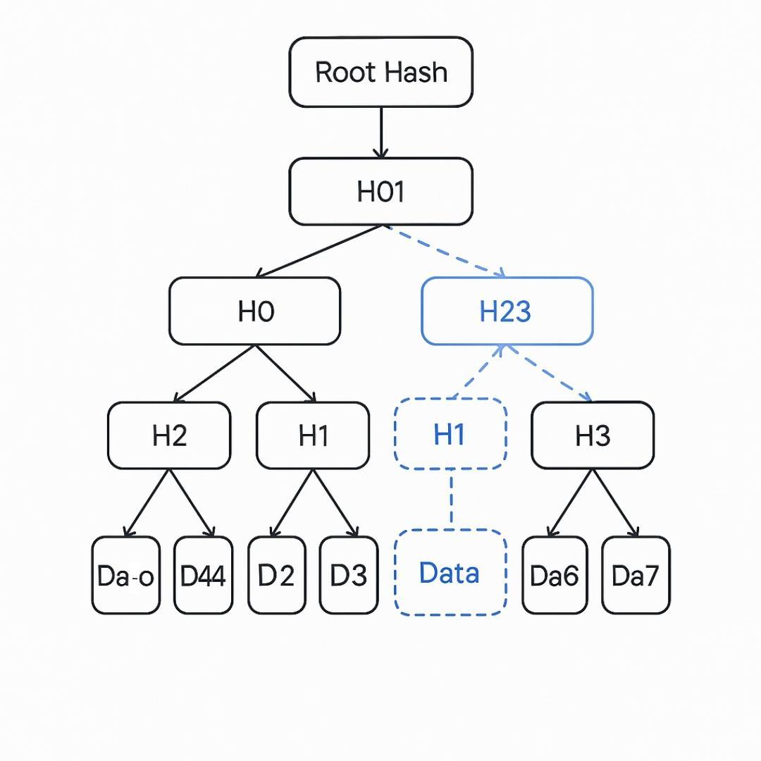

**1. What Are Merkle Trees?**

A Merkle tree (named after Ralph Merkle) is a binary tree in which each leaf node contains a cryptographic hash of a data block, and each non-leaf node contains the hash of its child nodes concatenated together. The top node, called the Merkle root, represents a unique fingerprint for all the data blocks under it.

**Structure:**

* Leaves: Hashes of transaction data.
* Branches: Hashes of concatenated child hashes.
* Root: Single hash summarizing all data in the block.

**In Astryx:** Each block in Astryx’s ledger has a Merkle root summarizing all transactions, so validating any transaction or set of transactions only requires a few cryptographic hash computations and the corresponding branch.

**2. Why Use Merkle Trees?**

Merkle trees provide three main benefits:

**A) Efficient Data Verification**

* When proving the inclusion of a specific transaction in a block, a user only needs to provide a small “Merkle proof”: the hashes along the path from that transaction up to the root.
* This enables light nodes (clients that do not store the entire blockchain) to efficiently verify the correctness of data without needing access to the full dataset.

**B) Integrity Guarantees**

* Because every hash depends on all underlying data, any attempt to tamper with one transaction changes the leaf’s hash, propagating changes all the way up to the root.
* A block’s Merkle root acts like a secure fingerprint if the root matches, the data is authentic.

**C) Scalability**

* Merkle proofs require only log2(*n*) hashes for validating data among *n* entries, making them highly scalable for large blocks or multi-shard architectures.

**3. Advanced Data Structures for Astryx**

Astryx extends the traditional Merkle tree framework by incorporating more advanced data structures in its architecture:

**A) Sparse Merkle Trees**

* Used for stateless client validation and scalable smart contract state proofs.
* They store vast datasets efficiently by filling unused branches with a default value, enabling rapid proof generation for accounts or asset ownership.

**B) Merkle Patricia Trees**

* A hybrid of Merkle and trie (prefix tree) structures for managing state storage.
* Highly suited for key-value pairs, such as account balances or smart contract variables, allowing rapid lookup, modification, and proof of authenticity of any element.

**C) Zero-knowledge Proofs (Zkps)**

* Zero-knowledge proofs are cryptographic protocols that allow one party to prove the validity of a statement without revealing the underlying data.
* ZK-SNARKs / ZK-STARKs: Astryx applies zero-knowledge succinct non-interactive arguments of knowledge to verify computations or transactions privately, without exposing input details.
* Integration: These proofs can commit large sets of data (e.g., transaction batches) with a single succinct proof published on-chain, reducing data bloat and improving privacy.

**D) Commitment Schemes and Data Availability Proofs**

* Commitment schemes encode data so that it can be revealed or verified later, without risk of tampering.
* Data availability proofs ensure that all data referenced in snapshots or blocks is accessible to validators and full nodes.

**4. Security Benefits in Astryx**

Implementing these structures gives Astryx key security advantages:

**A) Tamper-proof Storage**

* Each block and every transaction within inherits the security properties of its root hash. Any unauthorized change is instantly detectable.

**B) Lightweight Auditing**

* Third parties, auditors, or decentralized applications can test the validity of historical data or assets using only compact proofs.
* Even in multi-shard settings, individual transaction roots can be separately verified then merged for whole-chain consistency.

**C) Efficient Light Client Support**

* Merkle proofs and sparse Merkle trees make it possible for mobile and browser-based clients to safely interact with Astryx without downloading gigabytes of blockchain data.
* This expands the ecosystem for applications requiring instant or frequent verification (e.g., DeFi or NFT wallets).

**D) Resistance to Fraud and Replay Attacks**

* Every transaction commitment is cryptographically bound to a specific block and context.
* Replaying or duplicating old transactions is ineffective the hashes won’t match current block roots.

**5. Privacy and Confidentiality with Zero-Knowledge Proofs**

Zero-knowledge integration further elevates security:

* Private Transactions: Users can send, receive, or interact with smart contracts without revealing transaction details to the network, only proof of validity.
* Shielded Smart Contracts: Confidential data can be executed conditionally while proofs of correct computation (not data) are published on-chain.
* Auditable Yet Private: Network validators can audit system state or asset movement without uncovering user-sensitive data.
* Astryx’s ZK layers, adaptable for various proof schemes (SNARKs, STARKs, Bulletproofs), enable selective transparency regulators get compliance proofs, users get anonymity.

**6. Interoperability and Cross-Chain Proofs**

Merkle roots and ZKPs also facilitate secure interoperability between Astryx and other blockchains:

* Asset bridges can transfer tokens, NFTs, or data across chains using Merkle proofs for origin verification.
* Zero-knowledge proofs allow Astryx to validate cross-chain computations privately, vital for collaborative dApps or decentralized identity systems.
* Enables construction of “trust-minimized” oracles and relays, using cryptographic proofs rather than trusted third parties.

**7. Integrity Guarantees for Large-Scale Applications**

For enterprise, gaming, or financial applications, these foundations:

* **Guarantee trust:** Clients know, auditable by anyone, that records have not been altered or forged.
* **Reduce cost & complexity:** Fast verification enables millions of users to interact simultaneously without congested nodes or bottlenecks.
* **Prepare for future growth:** As Astryx scales, adding shards or integrated blockchains, Merkle root composition keeps security and integrity intact.

By architecting Astryx around Merkle trees, advanced trie structures, and zero-knowledge proofs, the platform upholds the highest standards of data integrity, security, and scalability. These data structures not only preserve the authenticity of every transaction and asset, but also ensure Astryx can scale to billions of daily operations, enable confidential computations, and interact seamlessly with other blockchain ecosystems.

Moving forward, the Astryx team will continue to research and integrate cutting-edge cryptographic techniques, including recursive ZK proofs and quantum-resistant hash functions, to safeguard its ecosystem against both current and future threats solidifying the platform as a trustless foundation for the next era of decentralized applications and digital assets.

1. **Alternative Blockchain Applications**

**Scope and Interoperability**

Blockchain technology has evolved far beyond its original use for peer-to-peer digital cash. As the sector matures, next-generation Layer 1 platforms like Astryx must support a diverse array of decentralized applications (dApps) across verticals including gaming, finance, artificial intelligence (AI), supply chain, and identity management. A critical piece for modern platforms is built-in interoperability the ability for Astryx to natively interact with other blockchains, eliminating data silos and unlocking new collaborative, cross-chain use cases.

**Gaming:** **Redefining Digital Experiences**

**Key Requirements**

* **Ultra-high throughput:** Real-time games require thousands of transactions per second (TPS) for in-game actions, trading, and loot drops.
* **Low latency:** Instant settlement ensures smooth gameplay, crucial for multiplayer, competitive, or eSports environments.
* **Programmable assets:** In-game items, currencies, and achievements can be secured and traded as tokens (NFTs or fungibles).
* **Fairness & anti-cheat:** On-chain randomness, transparent logic, and anti-fraud mechanisms protect player interests.

**Astryx's Competitive Edge**

Astryx, with sharding and parallel execution, targets sub-second finality and tens of thousands of TPS. This capacity supports massive virtual worlds and social games scaled to millions of users. Its flexible smart contract environment allows developers to create new genres play-to-earn (P2E), user-generated universes, and even autonomous game agents driven by on-chain logic.

Cross-chain interoperability provides real value: gamers can port assets across blockchains (e.g., skins from Ethereum-based games to Astryx worlds), access liquidity from other NFT markets, and participate in multi-chain tournaments or cross-platform metaverses.

* **Finance:** Decentralized Finance (DeFi) and Stable-Value Applications

Key Requirements

* **Composability:** Protocols must integrate smoothly lending, swaps, derivatives should interoperate securely within and across blockchains.
* **Low fees & high speed:** Efficient throughput for complex DeFi interactions, flash loans, high-frequency trading.
* **Programmable money & compliance controls:** Support for stablecoins, synthetic assets, and embedded KYC/AML modules.

**Astryx's Finance Stack**

Astryx empowers next-generation DeFi protocols by offering low costs, fast settlement, and robust customization. Projects can launch automated market makers (AMMs), insurance pools, prediction markets, and synthetic index funds using Astryx’s scalable architecture. Its compliance-friendly modules suit enterprise and regulated DeFi deployments.

With built-in interoperability, Astryx-based DeFi can access liquidity across multiple chains. Imagine a stablecoin minted on Astryx that’s usable on Ethereum and Solana, or cross-chain lending protocols where users borrow against assets held elsewhere. This fluidity unleashes new capital flows and arbitrage strategies while reducing fragmentation in global DeFi.

**AI Agents: Autonomous, On-Chain Intelligence**

**Key Requirements**

* Secure, extensible smart contract environment: Supports complex on-chain computation and verifiable agent behavior.
* Data accessibility: Seamless integration with off-chain data sources, IoT feeds, and oracles.
* Autonomy and interoperability: Agents function independently and coordinate via on-chain messaging potentially across multiple blockchains.

**Astryx's AI Layer**

Astryx is optimized for native AI support, enabling dApps composed of decentralized, autonomous agents. These can include:

* Predictive analytics for DeFi, gaming, and enterprise dApps.
* Autonomous market-making bots that operate transparently for lending, swaps, or asset management.
* IoT device coordination, where smart contracts manage supply chains, logistics sensors, or automated billing.
* Self-governing DAOs, where machine learning agents optimize decision-making or resource allocation.

**Interoperability is crucial:** AI agents deployed on Astryx might query on-chain data from Ethereum or trigger actions on Polygon, creating cooperative networks of bots and services. Astryx’s architecture supports secure cross-chain messages and verification, ensuring that autonomous decisions reflect the global state of Web3.

**Supply Chain: Transparent, Efficient, and Connected**

**Key Requirements**

* **Traceability:** Every movement of goods and data must be reliably logged from origin to endpoint.
* **Multi-party coordination:** Various vendors, shippers, regulators, and customers interact via secure, auditable processes.
* **Integration with legacy systems:** Blockchains must communicate with existing ERP, SCM, and IoT infrastructure.

**Astryx’s Supply Chain Solutions**

* With Astryx, stakeholders manage the entire lifecycle of goods from production to sale on-chain. Smart contracts automate payments, quality checks, customs reporting, and inventory tracking. Secure digital identities verify counterparties and certify provenance.
* Built-in interoperability allows Astryx-based supply chain dApps to synchronize with other blockchains critical to trade finance, insurance, or customs authorities. For example, a shipment tracked on Astryx can secure insurance on Ethereum, with documents notarized on Hyperledger removing bottlenecks, fraud, and compliance gaps.

**Identity: Decentralized and Privacy-Enhanced**

**Key Requirements**

* **Self-sovereign identities (SSI):** Users own and control profile data, share selectively, and revoke access at will.
* **Verifiable credentials:** Issuers create attestations (e.g., KYC, degrees, licenses), which users present to dApps and verifiers.
* **Privacy controls:** Zero-knowledge proofs and confidential computation ensure compliance while safeguarding user data.

**Astryx’s Identity Architecture**

* Astryx provides native support for decentralized identifiers (DIDs), credential issuance, and verifiable claims. Its modular structure lets users create composite reputations combining gaming achievements, financial activity, and work history into unified profiles usable on any dApp.
* Through interoperability, Astryx ID solutions interface with legacy blockchains like Ethereum (for DeFi access), government ID platforms, and enterprise permissioned ledgers. Users onboard once, then access services everywhere, from web3 finance to healthcare to social media, without repetitive verification or privacy risk.

**Built-In Interoperability: Breaking Down Blockchain Silos**

Interoperability is the foundation for a truly open ecosystem. Astryx’s native interoperability includes:

* **Cross-chain asset transfers:** Move tokens, NFTs, and data seamlessly between Astryx and chains like Ethereum, Solana, or Polygon via bridges or standardized messaging protocols (e.g., IBC, LayerZero).
* **Composable smart contracts:** Astryx contracts can call external contracts or trigger events on other blockchains, creating fluid "meta-applications" spanning multiple platforms.
* **Unified identity and credentialing:** Astryx users share identity and reputation data with dApps on any chain, dramatically improving onboarding and compliance.

Shared liquidity pools: DeFi protocols aggregate liquidity globally users on Astryx access pools originating on Ethereum or other L1s, increasing efficiency and lowering costs.

This interoperability removes friction. For users and businesses, Astryx becomes a portal to the entire Web3 universe instead of an isolated island. dApps leverage best-of-breed features (e.g., fast execution on Astryx, deep liquidity on Ethereum), enterprise supply chains integrate global partners, and new cross-industry collaborations become possible.

1. **Scripting and Smart Contracts in Astryx**

Scripting and smart contracts are at the heart of any modern Layer 1 blockchain platform. For Astryx, these components not only determine the capabilities of decentralized applications (dApps) and financial primitives but also impact developer adoption, network flexibility, and long-term ecosystem resilience. This section details the supported smart contract languages, the Astryx Virtual Machine (Astrix VM), and the comprehensive developer tools and onboarding processes designed to make Astryx highly productive, secure, and accessible for both new and established Web3 builders.

**Smart Contract Languages Supported**

**1. Astrix VM (Custom Smart Contract Platform)**

Astryx’s native virtual machine (Astrix VM) is designed for speed, safety, and extensibility, drawing on lessons from established platforms but introducing unique optimizations. At its core, Astryx VM supports a statically typed, high-level language inspired by Rust and Move a language specifically tailored for blockchain logic. This language offers several key advantages:

* **Memory Safety:** Borrowing principles from Rust, Astryx contracts avoid common vulnerabilities such as buffer overflows or use-after-free errors.
* **Formalized Asset Management:** Like Move, assets and tokens are first-class citizens with strict ownership rules. This reduces errors in transfer logic and helps audit DeFi applications.
* **Determinism and Resource Accounting:** All contract executions are deterministic and precisely metered, preventing exploits like infinite loops or resource exhaustion.

While the primary language is AstryxScript, the VM is modular, allowing future support for additional languages through transpilers or intermediate representations.

**2. EVM Compatibility**

To foster instant ecosystem growth and tap into the vast developer base already skilled with Ethereum’s tooling, Astryx also offers EVM-compatible smart contract layers. These layers run Solidity-based contracts natively, enabling:

* **Seamless Migration:** Projects built on Ethereum, Polygon, Avalanche, and other EVM chains can deploy on Astryx with minimal code changes.
* **Interoperable Libraries:** Developers can reuse countless open-source libraries (e.g., OpenZeppelin) and access standards like ERC-20, ERC-721, and ERC-1155.

EVM compatibility is maintained through an embedded compatibility module within Astryx VM. While not as performant as native AstryxScript, it allows rapid onboarding and parallel operation of AstryxScript and Solidity contracts.

**3. Move Language Support**

Recognizing the rapid rise of Move from the Aptos and Sui ecosystems, Astryx supports Move contracts via a dedicated runtime:

* **Asset-centric Programming:** Move excels at handling on-chain assets, enforcing strict ownership and preventing double-spends.
* **Security:** Move’s bytecode verifier and strict semantics minimize vulnerabilities in financial logic.
* **Parallel Execution:** Move contracts benefit from Astryx's parallel transaction processing, improving performance for high-volume dApps.

Thus, Astryx is distinctly multi-lingual: developers can choose AstryxScript for maximum performance, Solidity for compatibility, or Move for asset safety and parallelization.

**Developer Tools and Experience**

**1. Integrated Development Environments (IDEs)**

Astryx offers powerful IDE plugins for VS Code, JetBrains, and web-based editors, featuring:

* **Syntax Highlighting & Autocomplete:** For AstryxScript, Solidity, and Move, easing code writing and reducing errors.
* **Integrated Debugging:** Step through contract execution with breakpoints and state inspection.
* **Simulated Blockchain Node:** Run contracts locally against simulated blocks, using real network parameters.

**2. Command-Line Interfaces (CLI) and SDKs**

The Astryx CLI enables developers to:

* Scaffold contracts and dApp templates.
* Compile code for Astryx VM, EVM, and Move runtimes.

Deploy contracts to local testnets or the main network, with instant feedback and logs.

SDKs are available in TypeScript, Python, and Rust, facilitating dApp frontend and enterprise backend integration.

**3. Testing and Security**

Astryx provides a comprehensive suite for contract testing and audit:

* **Unit and Integration Tests:** Contracts can be tested in isolation or as part of complex dApp flows using a built-in test framework.
* **Formal Verification Tools**: Inspired by Move and Rust ecosystems, developers can formally verify correctness using both automated analyzers and theorem provers.
* **Static and Dynamic Analysis:** The toolchain includes linters and fuzzers to detect potential bugs, reentrancy issues, and gas inefficiencies.

**4. Simulation and Mainnet Forks**

Developers can fork live mainnet states into local environments to test contracts with real blockchain data before deployment. This reduces the risk of costly mistakes in production.

**5. Onboarding and Documentation**

Astryx’s onboarding experience aims to convert curious developers into power users:

* **Interactive Docs:** Tutorials, examples, and API references are presented as executable notebooks, letting users write, run, and modify code in-browser.
* **Live Workshops/Webinars:** Regular online events with core contributors to help new developers learn best practices and advanced logic.
* **Community Support:** Developers can get instant help through Discord, Telegram, and Forum channels monitored by Astryx engineers.

**6. DevNet & Grant Program**

* Astryx maintains always-online testnets (DevNets) for experimentation. Early adopters receive funding and mentorship through a strategic grant program targeting DeFi, gaming, and social dApps, with streamlined proposal and onboarding workflows.
* Developer Experience and Ecosystem Growth
* From day one, Astryx aims for an experience on par with, or better than, Ethereum and Solana:
* One-Click Deployments: Dapps can be deployed directly from the IDE or CLI onto testnets/mainnet.
* Instant Analytics: Dashboard tools provide real-time monitoring of contract activities, gas costs, user metrics, and security events.
* Open Source Libraries: AstryxScript and Move libraries (wallets, swaps, DAOs, NFTs) are available in the public registry, allowing rapid prototyping and innovation.
* Multi-language Bridges: Projects can migrate code or enable interoperability between AstryxScript, Solidity, and Move via standardized APIs and message passing protocols.

The tooling focuses squarely on developer productivity, security, and rapid time-to-market, understanding that ecosystem success hinges on enthusiastic builder adoption.

**Why This Architecture Matters**

By supporting AstryxScript, EVM, and Move, Astryx uniquely lowers the barrier for Web3 developers, while emphasizing advanced asset management, formal security, and high TPS. The platform’s tooling enables builders to move from "hello world" to full-scale production rapidly, with extensive support at every stage.

Astryx isn’t just another Layer 1 it’s an ecosystem aiming to harmoniously combine performance, security, and developer-friendliness. The goal is clear: give every developer, from indie creator to enterprise engineer, the ability to build next-generation dApps with confidence and speed.

1. **Astryx Platform Overview**

The Astryx blockchain platform is architected to be a next-generation Layer 1 solution that focuses on scalability, interoperability, developer experience, and security. At the heart of Astryx are its innovative account model, robust identity management system, flexible transaction types, and advanced cross-shard and cross-chain messaging mechanisms. This section delves into the principles and design choices behind Astryx accounts and transactions, illustrating how they collectively empower developers and users in a rapidly evolving decentralized ecosystem.

**Astryx Accounts: Account Model and Identity Management**

**1. Account Model Design**

Astryx adopts a dual-layered account structure, inspired by but improved upon Ethereum’s traditional model. There are two primary account types:

* **Externally Owned Accounts (EOAs):**

EOAs are held and controlled by users via private keys. They are the primary interface for end users, similar to “wallets” on other blockchains. EOAs can initiate transactions, sign off on smart contract calls, and participate in network governance.

* **Contract Accounts:**

These are programmatic accounts, governed by smart contract logic rather than user-held private keys. They can receive, hold, and manage tokens, execute autonomous functions, and interact with other contracts across shards and chains.

What sets Astryx apart is the integration of “multi-chain EOAs,” where a single identity is mapped across multiple shards and, potentially, bridged to external Blockchains. This enables seamless user experiences even in a sharded network.

**2. Identity Management**

Astryx’s identity system is built around the principles of privacy, interoperability, and compliance.

* **Decentralized Identifiers (DIDs):**

Each account is assigned a unique DID, following W3C standards. DIDs are non-custodial and self-sovereign, allowing users to control, prove, and manage their identity without reliance on third parties.

* **On-Chain Credential Management:**

Astryx supports verifiable credentials (VCs) linked to DIDs. These credentials issued by trusted organizations or DAOs can represent KYC status, reputation metrics, certifications, or other attributes. Smart contracts can read, verify, and act upon these credentials directly.

* **Privacy-Preserving Authentication:**

For sensitive interactions, Astryx employs zero-knowledge proofs (ZKPs). Users can prove aspects of their identity (e.g., age verification, KYC passed) without exposing the underlying data, dramatically reducing risk and friction for both users and enterprises.

* **Hierarchical Identity Linking:**

Accounts can establish layered identity trees, connecting EOAs, contract accounts, and external identities (such as a corporation’s Web2 backend) under a single root DID. This design allows complex organizational structures like DAOs, enterprise consortia, or multi-user teams to manage assets and permissions with granular security controls.

**3. Permissions and Governance Integration**

* **Role-Based Access Controls (RBAC):**

Smart contracts supporting DAOs or businesses can associate roles (e.g., admin, member, external auditor) with DIDs. Transactions and contract calls are authorized based on these roles, ensuring tight governance without sacrificing decentralization.

* **Flexible Recovery Mechanisms:**

To address usability and security, Astryx accounts can opt into multi-signature setups, social recovery (trusted contacts help restore access), or time-locked controls for sensitive operations. This reduces the risk of catastrophic asset loss from lost keys, making the platform more friendly for mainstream users.

**Messages and Transactions: Transaction Types, Message Passing Across Shards/Chains**

**1. Transaction Types**

Astryx expands well beyond simple transfer and contract calls, supporting a rich set of transaction paradigms:

* **Token Transfer:**

Moving fungible or non-fungible assets between accounts, both intra-shard and inter-shard. Transfers utilize advanced routing for optimal speed and cost efficiency.

* **Contract Invocation:**

Calling smart contracts, including passing complex data and even nested function calls across shards (thanks to native cross-shard communication).

* **Batch Transactions**:

Bundling multiple actions (transfers, contract calls, staking operations) into a single atomic transaction. This reduces costs and simplifies dApp logic.

* **Cross-Chain Transactions:**

Using Astryx’s interoperability protocol, accounts can initiate transactions that move assets, trigger smart contracts, or synchronize data between Astryx and external Blockchains (e.g., Ethereum, Solana). Transactions are completed via trustless bridges, with embedded fraud proofs for security.

* **Delegated Actions:**

Accounts can grant permissions to other accounts or contracts to act on their behalf within predefined limits. This supports user-friendly features such as gasless transactions and custodial wallet recovery.

**2. Message Passing Architecture**

Scalability and composability are powered by Astryx’s advanced message-passing system.

* **Cross-Shard Message Passing (CSMP):**

In a sharded network, data and assets must move fluidly across partitions. Astryx uses asynchronous yet verifiable message queues, supported by global consensus checkpoints. A message from shard A to shard B is routed through the network, assured to be processed atomically and securely key for dApps that span the entire ecosystem.

* Event Subscription and Notification:

Accounts and smart contracts can subscribe to events on other shards, chains, or contracts. For example, a DeFi protocol on shard X could react instantly when an asset crosses to shard Y, enabling advanced workflows and real-time automation.

* State Synchronization:

Regular state roots are propagated across shards and, if needed, to connected networks. This allows contracts to verify and trust remote state transitions, vastly improving composability but without sacrificing security.

**3. Interoperability Protocols**

* **Native Bridges:**

Astryx features built-in bridges that use light client proofs, cryptographic signatures, and time-locked transfers to securely pass messages and assets between Astryx and major external Blockchains.

* **Universal Message Format (UMF):**

All messages are formatted according to a universal schema, making it easy for developers to implement cross-platform logic while reducing the risk of incompatibility or vulnerability.

* **On-Chain Oracles and Relayers:**

For off-chain triggers and data feeds, Astryx integrates decentralized oracles, ensuring that messages between on-chain and external data sources remain trustworthy, verifiable, and censorship-resistant.

**4. Security and Finality**

* **Atomicity and Consistency:**

Transactions and message passes are either fully completed or completely reverted, even across complex cross-shard or cross-chain operations. Astryx’s consensus model ensures rapid finality (sub-second in optimal conditions) and prevents double-spends or race conditions.

* **Fraud Proofs and Watchers:**

For interoperability, every cross-chain message is subject to auditing by network “watchers.” If invalid or fraudulent behavior is detected, fraud proofs are submitted, automatically reverting malicious activity and penalizing attackers.

**5. Developer Experience Enhancements**

* **SDKs and APIs:**

Developers interact with accounts, identity layers, and cross-shard/chain messaging via high-level SDKs (supporting popular languages like Rust, TypeScript, and Solidity-EVM compatible syntax).

* **Testnets and Simulators:**

Sandboxed environments allow for full simulation of multi-shard, multi-chain message passing, helping prototype dApps that take advantage of Astryx’s advanced capabilities.

* **Composability and Upgradability:**

Contracts and accounts can be designed to upgrade permissions, message formats, and transaction workflows without disruptions supporting evolving business needs and protocol upgrades.

1. **Astryx State Transition Function**

**Mechanisms, Block Updates, and Cross-Shard/Chain Dynamics**

The state transition function is the backbone of every blockchain platform, governing how the distributed ledger evolves as new blocks are accepted and transactions are processed. For Astryx a next-generation Layer 1 architecture designed for scalability, interoperability, and high throughput the state transition function incorporates novel innovations in block proposal, finality, and shard/cross-chain communication. This section details both the underlying principles and practical mechanisms that keep Astryx secure, up-to-date, and adaptable for large-scale decentralized applications.

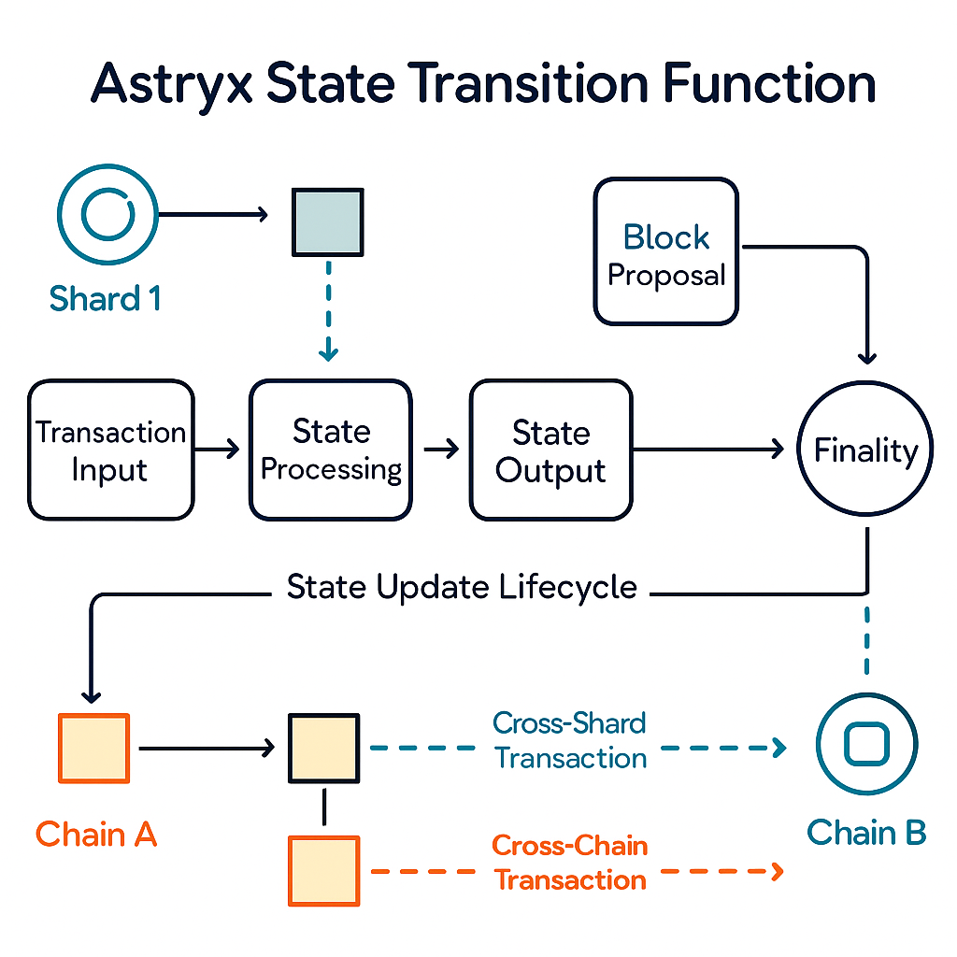

**1. Theoretical Model: State, Transactions, and Functions**

Every blockchain, at its core, is a state machine. The state (S) is a snapshot of all relevant data at a given block height account balances, contract data, validator information, and more. The state transition function (STF) maps an old state and a set of incoming valid transactions (T), producing a new state:

*Sn+1 = STF (Sn, Tn)*

In Astryx, this transition includes factoring in cross-shard and cross-chain messages, not just local transactions, since its architecture is *modular and sharded* by design.

**2. Block Proposal and Finality: The Heartbeat of State Updates**

**A. Block Creation and Proposal**

Astryx operates using a hybrid consensus protocol (assumed e.g., BFT over PoS), where validators compete or are selected to propose new blocks. Each proposed block contains:

* A batch of local transactions relevant to the shard or chain;
* Cross-shard/cross-chain messages received, to be processed;
* Metadata: timestamps, proposer identity, cryptographic proofs.

The validator set for each shard is dynamically rotated, increasing security and reducing risk of collusion.

**B. Transaction Validation And Execution**

Within each proposed block, all transactions and messages are validated for:

* Signature authenticity and sufficient balances;
* Contract logic correctness (gas/computation resource check);
* Compliance with protocol rules (e.g., nonce, double-spend prevention).

Smart contracts are executed in Astryx’s native VM, updating state as specified. Failed transactions revert state and may incur base fees.

**C. Consensus And Finality Events**

Finality in Astryx employs a dual-layer system (e.g., fast optimistic finality + slow provable finality):

* **Optimistic Finality:** Blocks tentatively enter the chain once a supermajority of validators sign off.
* **Provable Finality:** Periodically, validator committees produce cryptographic proofs (zero-knowledge, BFT, or sidechain anchoring) that cement blocks as irreversible. Finality events mark clear points when all parties agree on a state update.

This approach ensures near-instant transaction feedback while robustly defending against forking or malicious attempts.

**3. Cross-Shard and Cross-Chain State Updates**

Astryx’s architecture divides its blockchain into multiple shards (independent state spaces) and includes a cross-chain bridge protocol to interact with external networks.

**A. Cross-shard Communication**

Operations involving multiple shards require coordination so that inter-shard transactions commit atomically and securely.

* **Message Passing Mechanism:** Each transaction targeting another shard is encapsulated as a message, broadcast via Astryx’s inter-shard communication protocol.
* **Inbox/Outbox** **System:** Shards maintain inboxes for incoming cross-shard messages; messages are processed in order of arrival, included in the block proposal/execution cycle.
* **Atomicity Guarantees:** Transactions involving multiple shards use lock-and-unlock or two-phase commit schemes to ensure either every part of the operation succeeds or none do, maintaining consistency.

Sharding increases TPS by parallelizing transaction processing, while cross-shard mechanisms ensure unified system state.

**B. Cross-Chain Updates**

Astryx supports connections to external blockchains (Ethereum, Solana, etc.) using bridge contracts and relayers:

* **Bridge Contracts:** Special smart contracts monitor locked assets and relay transfer proofs between chains.
* **Light-client Verification:** Validators or relayers verify state transitions and signatures on external chains, submitting proofs to Astryx, which processes them like native transactions.
* **Consensus on External Events:** Only after sufficient validator confirmation (threshold signatures or ZKP attestation) do cross-chain operations affect Astryx’s state.

**Example:** If an asset is bridged from Ethereum to Astryx, the Ethereum bridge contract emits an event and locks the asset; Astryx validators verify and update state by minting a wrapped token, reflecting the external operation.

Robust cross-chain support enables fluid interoperability and asset transfer, a critical feature for DeFi and multi-chain dApps.

**4. Security and Integrity of State Transitions**

Astryx employs multiple lines of defense for state accuracy and tamper-resistance:

* **Merkle Trees & ZK Proofs:** Every block encodes the state root using a Merkle tree; zero-knowledge proofs provide succinct validity evidence for cross-shard or cross-chain updates.
* **Slashing & Penalization:** Validators proposing invalid or malicious state transitions are penalized via stake slashing, deterring attacks.
* **Auditability:** State changes tied to each block and cross-shard/cross-chain event are fully auditable.

**5. Network Upgrades and Fork Handling**

When protocol upgrades are required (from bug fixes to feature additions), Astryx’s governance triggers a soft fork or hard fork event:

* **Upgrade Blocks:** Marked explicitly, upgrade blocks trigger version checks and contract migrations as needed.
* **Safe Transitions:** Cross-shard and cross-chain protocols include mechanisms for pausing inter-shard/chain operations during upgrades to avoid inconsistencies.

This ensures seamless evolution while maintaining overall system stability.

**6. Real-World Scenarios**

**A. Multi-shard Dapp Invocation**

A game operates in one shard but needs to pay a user in another. The payment transaction is routed via cross-shard messaging, ensuring both game state and account balances update atomically.

**B. Cross-chain Asset Transfer**

A stablecoin moves from Ethereum to Astryx, and later back. Bridge contracts and validator attestation synchronize both chains’ states, ensuring proper custody and minimizing risk of double-spend.

**7. Performance and Future Horizons**

Astryx’s modular state transition system supports:

* **Scaling to 100,000+ TPS:** Thanks to parallel transaction processing and efficient cross-shard controls.
* **Sub-second Finality:** User transactions settle rapidly, supporting gaming, finance, and real-time apps.
* **Seamless** **Interoperability:** Integration with external networks extends Astryx’s ecosystem and user base.

Future upgrades may add native L2 support, enhanced AI integration, and dynamic sharding for even higher resilience and adaptability.

1. **Code Execution**

**1. Introduction: The Role of Code Execution in Astryx**

At the heart of any blockchain platform, code execution powers smart contracts, decentralized applications, and novel features that differentiate the chain. In the Astryx Layer 1 platform, code execution is facilitated by the Astryx Virtual Machine (AVM), a purpose-built environment designed to deliver high levels of security, performance, extensibility, and optionally native support for artificial intelligence (AI) and machine learning (ML) workloads. This section comprehensively outlines AVM’s architecture, its unique security mechanisms, resource management policies, extensibility strategies, and the transformative potential of AI/ML-native smart contracts.

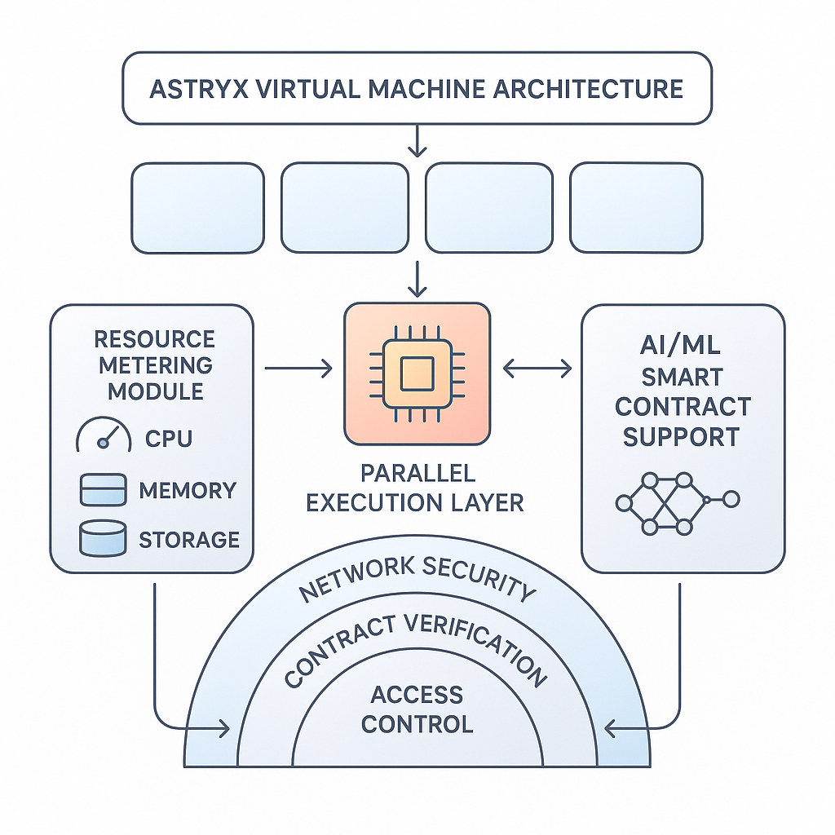

**2. Astryx Virtual Machine Architecture:** Structure and Execution Model

The AVM is a lightweight, modular, and high-throughput execution environment optimized for decentralized apps (dApps), complex financial instruments, and next-gen Web3 use cases. Like the Ethereum Virtual Machine (EVM), it provides abstraction between smart contract code and physical computation, allowing developers to write, deploy, and interact with code that runs identically across all nodes.

However, AVM advances beyond legacy models in several critical ways:

* Hybrid Instruction Support: The AVM is compatible with multiple programming languages including Solidity (EVM-compatible), Rust (for high-performance needs), and Python (for AI/ML applications) making onboarding easier for diverse developer teams.
* Parallel Execution: The VM, inspired by Solana’s Sea Level and Move-based architectures, executes transactions concurrently across state shards, reducing latency and improving throughput for high-volume apps like DeFi protocols or gaming ecosystems.
* Deterministic State Updates: AVM ensures code execution produces deterministic outcomes, even for complex contracts, by enforcing strict bytecode validation and sandboxed state transitions.
* Modular Runtime: The VM is upgradable via governance proposals, allowing rapid incorporation of new features or security patches without hard forks.

This architecture lays the foundation for secure, high-performance on-chain computation while remaining accessible to developers and adaptable to emerging needs.

**3. Security Model:** Safeguarding Smart Contract Execution

Security remains a paramount concern in blockchain platforms, given the billions of dollars at risk and the constant evolution of attack vectors. AVM’s defense-in-depth approach includes:

**A) Deterministic Execution and Sandboxing**

AVM enforces deterministic execution every node reaching the same result for every transaction by validating bytecode and restricting contract behavior within defined sandboxes. This prevents issues such as reentrancy attacks, which plagued older platforms, and allows for safe parallel execution.

**B) Native Formal Verification**

AVM supports formal verification at the bytecode level, enabling developers to mathematically prove contract correctness and absence of critical bugs or vulnerabilities prior to deployment. This is particularly vital for AI/ML-powered contracts, which can introduce non-traditional attack surfaces.

**C) Layered Permission System**

Smart contracts and dApps can be programmed with granular, role-based permissions, restricting actions to trusted entities and enabling robust DAO governance. Inter-contract calls are controlled via whitelist mechanisms, minimizing the risk of unauthorized invocation.

**D) On-chain Auditing and Upgrade Controls**

Upgradeability is managed via multisig or DAO-sponsored governance modules; code changes require approval from a broad set of stakeholders. The on-chain auditing system tracks contract state, call history, and recent events, making bugs and abnormal behavior easily traceable.

**E) AI/ML-specific Protections**

For AI/ML workloads, AVM restricts resource access (e.g., CPU cycles, model files) and blocks unsafe operations (e.g., dynamic code injection, arbitrary external calls), ensuring that machine learning models integrated on-chain do not become vectors for denial-of-service or data leakage.

**4. Resource Constraints:** Performance, Fairness, and Sustainability

To scale efficiently and ensure fair use of shared computational infrastructure, AVM enforces robust resource management:

* Gas-based Metering: Each transaction or contract invocation is priced via gas units reflecting CPU, memory, and storage consumed. Dynamic pricing adjusts for network load, incentivizing efficient code and deterring spam or resource hogging.
* Quota Enforcements: Validator nodes allocate resources on a per-contract and per-user basis, preventing runaway processes or monopolization of the AVM by single entities. For AI/ML tasks, specialized quotas (e.g., model training cycles) are tracked and capped.
* Cost Predictability: Astryx’s fee model is designed for consistency, allowing developers and enterprises to forecast operational costs even for compute-intensive smart contracts.
* Resource Auctions for AI/ML: When large-scale AI/ML workloads need allocation (e.g., distributed training or inference), AVM uses on-chain auctions to distribute resources efficiently and transparently.

This system fosters a sustainable ecosystem, balancing developer freedom and infrastructure protection.

**5. Extensibility:** Adapting to Rapidly Evolving Use Cases

AVM is engineered for extensibility, future-proofing the platform:

* Plugin-based Architecture: Developers can add new language runtimes, virtualized hardware modules (TPUs for ML), or data providers via audited plugins, subject to governance controls.
* Upgrade Paths: The VM supports soft upgrading without hard forks, enabling community-driven innovation in contract functionality and resource management.
* Interoperability Bridges: AVM can natively interoperate with external blockchains, messaging protocols, and data sources, expanding Astryx’s utility for cross-chain, cross-domain use cases.

Such adaptive infrastructure is critical for remaining relevant in the face of rapid technology shifts.

**6. Native AI/ML Support:** Smart Contracts that Learn and Adapt

A hallmark feature of Astryx’s virtual machine is native support for AI and ML workloads within smart contracts. This unlocks unprecedented possibilities:

**A) On-Chain Model Training and Inference**

Developers can deploy machine learning models directly into smart contracts, enabling use cases such as on-chain audit, automated risk scoring, predictive analytics, dynamic pricing, or personalized content in gaming and social dApps.

**B) Distributed, Trust-minimized Data Handling**

AI contracts can ingest on-chain and off-chain data (via trusted oracles) for federated learning models trained across multiple nodes without sharing raw data enhancing privacy and reliability.

**C) Automated Decision Making and DAOs**

AI-powered contracts expand DAOs’ efficiency, making governance decisions based on real-time analytics, sentiment analysis, or incentive optimization.

**D) Security and Compliance Automation**

Machine learning models can monitor blockchain activity for anomalies, automatically flagging or halting high-risk transactions to protect users from hacks, wash trading, or money laundering.

**E) Developer Tooling**

Astryx provides comprehensive libraries and templates compatible with popular ML frameworks like TensorFlow, PyTorch for integrating AI into smart contracts, democratizing access to advanced technology for all developers.

1. **Blockchain and Mining**

**Block Creation, Finalization, Fork Handling, and Network Upgrades**

**Introduction**

In Astryx a next-generation Layer 1 blockchain block creation, finalization, and network security are fundamental to building a scalable, decentralized ecosystem that can support real-time applications, large-scale enterprises, and emerging technologies such as AI and IoT. This section demystifies how Astryx secures its ledger, efficiently achieves consensus, manages forks, and upgrades its protocol, all while balancing speed, decentralization, and resilience.

**1. Block Creation:** Consensus Mechanism and Validator Roles

Astryx employs a hybrid consensus algorithm that marries the efficiency of modern Proof-of-Stake (PoS) systems with Byzantine Fault Tolerance (BFT) elements to maximize speed, security, and energy efficiency. The process of creating blocks unfolds as follows:

* **Validator Selection**

Validators are chosen in each block round through a randomized, stake-weighted lottery. This selection mechanism prevents manipulation and concentration of power, encouraging decentralization. Stakeholders can delegate their tokens to validators, increasing community participation and security assurance.

* **Proposing Blocks**

The selected validator proposes a block composed of valid transactions, messages, and state changes. Transaction ordering is handled using parallel execution, leveraging sharding to process transactions simultaneously across multiple chains or partitions. This drastically boosts throughput potentially reaching tens of thousands of TPS (transactions per second).

* **Block Validation and Voting**

Validators validate the proposed block’s contents by executing the smart contracts and applying state changes. Using BFT voting, validators confirm the correctness of the block through multiple rounds of messaging, which permits rapid convergence on the next valid state and mitigates risks of Byzantine actors.

* **Finalization**

When a supermajority (e.g., 2/3+ of active validators, weighted by stake) agrees, the block is finalized. This finalization is cryptographically proven and irreversible, giving immediate confirmation to users and applications. Astryx targets sub-second finality for most transactions a critical feature for on-chain gaming, DeFi, and enterprise use cases.

* **Energy Efficiency**

As opposed to Proof-of-Work chains, Astryx’s PoS+BFT system drastically reduces energy consumption. Validators require computational resources only to validate blocks and participate in consensus messaging, not to solve resource-intensive cryptographic puzzles.

**2. Fork Handling: Ensuring Consistency and Liveness**

Despite robust consensus, blockchain networks may occasionally experience forks temporary splits in the ledger caused by delayed validator messaging, network latency, or adversarial actors. Astryx’s fork handling is designed for rapid resolution and minimal disruption:

**Fork Causes**

**Forks typically arise when:**

* Multiple validators propose conflicting blocks simultaneously due to network latency.
* An adversary or faulty validator attempts to propagate a malicious block.

**Prevention and Detection**

Astryx reduces fork frequency with synchronized block intervals, deterministic validator selection, and aggressive finalization windows. Validators continuously monitor block propagation and challenge conflicting proposals using built-in detection routines.

**Resolution Process**

**When forks occur:**

1. Validators compare competing blocks and use stake-weighted voting to select the canonical chain the block with the most legitimate confirmations becomes the accepted ledger state.
2. Rejected blocks are marked as orphaned and retained temporarily in network memory for audit and forensic purposes.

* **Economic Incentives and Slashing**

To discourage malicious activity, Astryx implements slashing logic. Validators who sign conflicting blocks or act against protocol rules face automatic stake reductions and temporary bans. This economic deterrence aligns incentives for validators to act honestly and efficiently.

* **Minimal Impact Design**

Astryx’s rapid finalization ensures that the window for forking is small, limiting uncertainty for users. Most forks are resolved within a second, and finalized blocks are never reverted, guaranteeing transactional certainty for dApps and enterprise integrations.

**3. Network Upgrades: Protocol Evolution Without Disruption**

Blockchain networks must evolve to remain secure, performant, and competitive. Astryx uses a sophisticated upgrade mechanism combining on-chain governance, modular software architecture, and transparent deployment schedules.

* **On-Chain Governance**

Major protocol changes such as introducing new consensus algorithms, modifying transaction fees, or deploying new virtual machine features are proposed as “upgrade proposals” submitted on-chain. Token holders and validators vote using a quadratic or stake-weighted mechanism, ensuring broad, democratic participation.

* **Safeguards and Testing**

All upgrade proposals undergo rigorous testing via Astryx’s testnet, where bugs, exploit risks, and performance bottlenecks are identified before mainnet deployment.

* **Upgrade Execution**

When a proposal achieves sufficient consensus (e.g., 75%+ approval), validators prepare for the upgrade during a designated epoch change. Upgrades are orchestrated so that old and new software versions are network-compatible for a transition period, preventing desynchronization.

* **Handling Hard and Soft Forks**

In rare cases, contentious upgrades may create hard forks two incompatible ledger versions. Astryx’s governance is designed to minimize such events by requiring broad agreement and extensive pre-upgrade dialogue. If a hard fork occurs, social consensus and ecosystem actors (exchanges, dApps) typically signal which chain will remain canonical.

* **Backward Compatibility and Modular Design**

Astryx’s protocol is built on a modular basis: new features are added as opt-in modules, and old modules can be phased out gradually. This minimizes disruption for dApps, users, and infrastructure providers and allows for seamless integration of new technologies such as zk-proofs or AI frameworks.

* **Communication and Support**

Users, developers, and enterprises are notified of scheduled upgrades well in advance via documentation, on-chain notifications, and validator dashboards. Support teams provide migration guides and technical assistance, ensuring migrations are smooth and user assets remain safe.

1. **Applications**

**Token Systems**

* **Token Standards:**

Astryx natively supports robust standards for both fungible and non-fungible tokens, leveraging lessons from Ethereum’s ERC-20 and ERC-721 while introducing improvements for security, efficiency, and interoperability.

* **Fungible Tokens:** Astryx FT-Standard streamlines token creation for currencies, utility tokens, and staking assets. Key features include built-in support for automated compliance checks, on-chain governance hooks, and low-cost mint/burn operations.
* **Non-Fungible Tokens (NFTs):** The Astryx NFT-Standard enables the creation of unique digital assets, ranging from collectibles and event tickets to domain names and digital rights. Metadata is extensible, allowing rich integrations with decentralized storage and real-world asset representations.
* **Smart Contract Templates:** Out-of-the-box templates ensure that token contracts are easily auditable and upgradable, enabling developers to bootstrap projects securely.

**Use Cases and Interoperability:**

* **Digital Art & Collectibles:** Artists and game designers release NFTs representing exclusive artwork or in-game items, with seamless transferability across marketplaces and metaverse platforms.
* **Programmable Money:** Fungible tokens are programmed for automated splits, vesting, payroll, or royalty payments, empowering DeFi platforms and digital businesses.
* **Token Bridges:** Astryx’s interoperability protocols facilitate trustless token migration between blockchain networks (Ethereum, Solana, etc.), unlocking liquidity and cross-chain DeFi.

**Interoperability Focus:**

Cross-Chain Compatibility: Astryx implements industry-standard bridging modules and decentralized exchanges (DEXs) to ensure that tokens are not siloed on a single network. This enables users to freely move assets and participate in DeFi ecosystems globally.

* **Open API Access:** Developers can tap standardized APIs for token events, allowing for wallet and dApp integrations without custom code rewrites.

**Financial Derivatives and Stable-Value Currencies**

**DeFi Primitives Supported:**

Astryx provides a secure foundation for launching decentralized finance (DeFi) primitives:

* **Decentralized Exchanges (DEXs):** Support for automated market makers (AMMs), limit order books, and lending protocols.
* **Synthetic Assets: Creation** of derivatives tracking the value of stocks, commodities, or interest rates, allowing users global access to financial instruments.
* **Stablecoins:** Both collateralized and algorithmic stablecoins are supported to facilitate predictable, low-volatility transactions and remittances.

**Stablecoin Integrations:**

* **Native Frameworks:** Astryx’s compliance modules ensure stablecoins meet global regulatory standards, including regular transparency audits and automated resolution of disputes.
* **Multi-Currency Support:** Enterprises can issue stablecoins pegged to major fiat currencies or baskets, allowing seamless global transactions and hedging against volatility.

**Advanced Derivatives:**

* **Options & Futures:** Smart contracts facilitate the trade and settlement of on-chain options and futures, broadening access to risk management tools traditionally reserved for institutional investors.
* **Interest-Bearing Tokens:** Integration of yield-earning savings accounts or liquidity pool deposits encourages mainstream adoption by offering competitive returns versus legacy financial systems.

**Enterprise Grade Security:**

Built-in insurance pools and circuit-breaker functions protect users from losses due to protocol bugs or market manipulation, while modular DeFi infrastructure supports rapid innovation and composability.

**Identity and Reputation Systems**

**On-Chain Identity:**

Astryx introduces privacy-preserving, self-sovereign identity modules:

* **Decentralized Identifiers (DIDs):** Each user and organization may register encrypted identities controlled cryptographically, forming the backbone for trust-minimized interactions.
* **Verifiable Credentials:** Issuance of credentials (KYC status, age, certifications) by approved validators, allowing verification without revealing private information.

**KYC/AML Modules:**

* **Pluggable Compliance:** dApps and financial institutions integrate AML (Anti-Money Laundering) and KYC (Know Your Customer) checks governed by smart contracts, ensuring regulatory participation without centralizing user data.
* **Selective Disclosure:** Astryx leverages zero-knowledge proofs (ZKPs) to enable users to prove eligibility for services (like country of residence or creditworthiness) without leaking personal info.

**Reputation Scoring:**

* **Incentive Engine:** On-chain reputation scores are algorithmically calculated from user activity, contract audits, and peer feedback. High-reputation users and projects may earn preferential access to funding, discounts, and voting rights.
* **Spam and Fraud Prevention:** Automated scoring helps dApps filter out bad actors, enhancing ecosystem security and reliability.

**Decentralized File Storage**

**Storage Methods:**

Astryx’s file storage layer, built in partnership with decentralized networks (e.g., IPFS, Filecoin, Arweave), enables permanent, censorship-resistant data preservation.

* **Content Addressing:** Users and dApps upload files referenced by cryptographic hashes, ensuring immutability.
* **Redundancy and Recovery:** Data is replicated across thousands of independent nodes, providing robust backup against loss or censorship.
* **Programmable Storage Policies:** Smart contracts automate file retention, access rights, and archiving for compliance and business purposes.

**Enterprise Partnerships:**

Secure Document Management: Enterprises deploy shared ledgers for employee records, supply chain documents, and audit trails.

* Media Streaming: Content creators host videos, music, and interactive experiences, charging micropayments through integrated token systems.
* **NFT Metadata Storage:** NFT creators store high-resolution art, certificates, or user-generated content directly on-chain, avoiding risks of “broken image” or metadata loss.

**Decentralized Autonomous Organizations (DAOs)**

**Governance Tools and Frameworks:**

Astryx equips DAOs with modular, transparent, and secure governance infrastructure:

* **On-Chain Proposals:** Members submit governance proposals directly on the blockchain, with all actions (votes, results, implementation) transparently logged.
* **Staking and Quadratic Voting:** Token holders stake assets to participate in decision-making, with quadratic voting mitigating the influence of large holders and improving democratic representation.
* **Treasury Management:** DAOs utilize multi-signature wallets and programmatic expenditure controls to manage pooled resources for projects, grants, and operations.

**Native DAO Framework:**

Constitution Templates: Ready-made legal frameworks help communities and enterprises quickly launch compliant DAOs.

* **Reputation-Based Governance:** Voting weights dynamically adjust based on contribution history and expertise, incentivizing sustained engagement.

**Enterprise-Scale DAOs:**

* **Supply Chain Consortia:** Logistics companies form DAOs to oversee global shipment tracking, dispute resolution, and process automation.

**Nonprofits and Social Impact:** NGOs use Astryx DAOs for crowdfunding, allocating grants, and transparently reporting results.

**Further Applications**

**IoT Innovations:**

Astryx empowers machine-to-machine transactions and decentralized device management:

* **Sensor Payment Flows:** IoT devices autonomously transact for bandwidth, data, or compute resources using micro-payments.
* **Decentralized Authentication:** Devices register on-chain, securely proving identity and access to networks or applications.

**Supply Chain Solutions:**

* **End-to-End Tracking:** Every product’s journey, from manufacturing to delivery, is jointly recorded by all supply chain participants, enhancing visibility and fraud prevention.
* **Compliance Automation:** Smart contracts execute product recalls, tariff calculations, and certifications in real-time.

**Enterprise Solutions:**

* **CBDC Pilots:** Central banks develop digital currencies on Astryx, leveraging its compliance, privacy, and interoperability features.
* **Healthcare & Legal:** Patient records, legal documents, and intellectual property are securely managed, with automated access granted only to authorized parties.

**Innovative Ventures:**

* **AI-Agent Integration:** Automated agents interact on-chain to perform predictive analytics, generate insights, and make autonomous decisions in finance, gaming, and enterprise operations.
* **Insurance Protocols:** Peer-to-peer and algorithmic insurance models minimize intermediaries, reduce costs, and expand coverage globally.

1. **Miscellaneous and Concerns**

This section covers miscellaneous technical and economic factors crucial for the success, resilience, and integrity of the Astryx Layer 1 blockchain. These considerations ranging from security and compliance to scalability and validator centralization often define long-term viability and enterprise appeal.

Security, Privacy, and Compliance

Security

Astryx is architected with robust security protocols at every layer. Transaction validation employs cryptographic signatures and deterministic state transition rules, ensuring all ledger changes are verifiable. The platform incorporates regular peer-reviewed audits of smart contract templates, runtime components, and core protocol upgrades. Adversarial testing and bug bounties encourage community-driven hardening. Network-level protections, such as DDoS prevention and node reputation scoring, mitigate spam and targeted attacks.

Privacy Technologies

Privacy is embedded via zero-knowledge proofs (zk-proofs), allowing transaction integrity without publicly exposing sender, receiver, or amount. This mechanism enables confidential transactions, shielding business-sensitive or personal details from chain observers. Optional stealth addresses and ring signatures further obscure transaction trails.

Compliance: AML/KYC & Regulatory Engagement

For regulated markets, Astryx supports native modules for AML (Anti-Money Laundering) and KYC (Know Your Customer). These modules can be invoked by dApps to check user status against global sanctions databases or mandate identity verification during onboarding. Governance committees actively engage with global regulators, participating in open standards (e.g., FATF’s Travel Rule compliance, UNCITRAL’s digital asset frameworks) to align Astryx with changing policy landscapes without compromising decentralization.

Modified GHOST Implementation (if relevant)

The Modified GHOST (Greedy Heaviest Observed Subtree) protocol, as adapted by Astryx, improves block selection and finalization over conventional longest-chain algorithms. GHOST accounts for uncle/aunt blocks (“orphans”), rewarding participants for contributing to network activity even if their block is not immediately part of the canonical chain. This approach increases fork tolerance, boosts decentralization incentives, and shortens settlement time. By further weighting block selection based on node reputation and stake, Astryx reduces attack surfaces seen in simple chain-based approaches, enhancing both security and scalability.

Fees: Transaction Fee Model

Astryx employs a dynamic, tiered fee structure:

Base Layer Fees: Minimal and predictable for standard transactions, aiming to keep costs <$0.001, supporting micropayments and high-frequency applications.

Priority Fees: Users may pay extra for urgent transactions, with an algorithmic scheduler ensuring fair access during periods of congestion.

Fee Recycling: A fraction of collected fees is allocated to validator pools, ecosystem treasury, and rebated to power users, boosting network activity.

Impact: This model optimizes usability by preventing fee spikes during high demand one of Ethereum’s historical pain points. The transparency and predictability of Astryx fees support mass adoption for retail users, gaming, and enterprise integrations.

Computation and Turing-Completeness

Astryx’s virtual machine (AstrixVM) is Turing-complete with carefully bounded execution limits. Gas metering tracks computational resources used by each smart contract invocation, preventing infinite loops and unsustainable resource drains. Contracts exceeding preset gas limits are terminated, minimizing network abuse.

Resource Management: Developers are incentivized to optimize code, as high gas usage directly increases transaction cost. Astryx supports deterministic off-chain computation modules complex computations can be performed off-chain and verified via succinct proofs on-chain, enhancing scalability.

Sustainability: Fees from computation are partly used to fund infrastructure maintenance and further research into energy-efficient execution environments, ensuring long-term protocol health.

Currency and Issuance

Issuance Schedule

Astryx’s native token is distributed via a hybrid scheme:

Genesis Allocation: 20% locked for core team, 15% strategic investors, 50% for community and validators, 15% ecosystem treasury.

Block Emissions: Ongoing issuance follows a declining inflation schedule starting at 5% annually and reducing by 0.5% per year until reaching a 1% ongoing inflation rate.

Staking Rewards: Active validators receive a majority share of emissions based on stake and uptime, with a cap to prevent excessive inflation.

Inflation/Deflation Controls

Burn mechanisms (fees sent to irretrievable addresses) adjust supply downward during periods of high activity. DAO governance can vote to revise issuance or burn rates based on economic conditions, preventing runaway inflation while maintaining long-term security.

Long-Term Supply Growth Rate

Astryx models supply growth to ensure sustainability and incentive alignment:

Initial Projections: Targeting 200M tokens after five years, with a tapering growth curve.

Sustainability Analysis: Mitigating risks of rapid supply dilution, which can undermine token value, Astryx integrates community oversight, routine scenario modeling, and stress tests. Long-term, supply growth approaches equilibrium with network expansion and transactional volume to prevent unwarranted inflation or value stagnation.

Treasury Management: A portion of supply is reserved for future grants or critical ecosystem funding, with spending milestones and periodic burn votes to minimize excess.

Mining/Validation Centralization Prevention

Astryx deploys multiple decentralization mechanisms:

Stake Caps: Maximum stake per validator node, ensuring no single entity dominates consensus.

Randomized Validator Selection: Instead of ranking purely by stake, Astryx uses verifiable random selection for block proposers, with additional reputation weighting based on historical performance.

Multi-Region Validator Incentives: Targeted grants for geographic diversity reduce risk of regional concentration. Validators in underserved zones receive subsidies, securing the network against jurisdictional risks.

Slash Conditions: Severe penalties for colluding or double-signing, deterring cartel formation.

This architecture ensures both security and credibility, even as network valuation grows.

Scalability

Architecture Features:

Sharding: Network state and transaction processing is divided among multiple shards, each capable of handling independent operations. This massively parallelizes throughput without endangering security.

Parallel Execution: Within each shard, transactions are processed concurrently, leveraging multicore hardware and deterministic ordering to avoid state clashes.

Cross-Chain Communication: Astryx integrates native bridges and lightweight messaging protocols (e.g., SPV proofs, light clients) to enable seamless interactivity with Ethereum, Solana, and other major chains.

Performance Targets:

TPS (Transactions Per Second): Target baseline is 50,000 TPS, upgradable by adding shards or validator subnets; stress-tested during simulated network events to verify stability.

Latency Goals: Sub-second block finality (target <0.8s), suitable for real-time applications like gaming and financial trading.

Stress Test Results: In pre-launch and public testnets, Astryx sustained peak throughput for multi-hour periods with no observable centralization or stability loss. Performance monitoring is ongoing with adaptive throttling to handle software bugs or unforeseen traffic spikes.

Summary and Forward Path

The considerations addressed here reflect Astryx’s commitment to enterprise-grade security, compliance, economic stability, robust decentralization, and cutting-edge scalability. Each technical and governance choice is made to balance performance with long-term health ensuring Astryx becomes a durable foundation for modern decentralized applications and economic innovations. With routine upgrades and transparent governance, Astryx can evolve alongside the blockchain landscape and its regulatory, commercial, and technical demands

1. **Conclusion**

**Recap of Astryx’s Vision**

Astryx emerges from the conviction that blockchain technology must move beyond the bottlenecks constraining today’s most popular Layer 1 platforms. Where existing networks like Ethereum or Solana provide proof of blockchain’s capabilities, they have also exposed significant limits: scalability throttles innovation, high transaction costs inhibit participation, and developer experiences are often convoluted and siloed.

Astryx’s vision is of an open, adaptable, and future-ready Layer 1 platform optimized for global-scale, real-time decentralized applications. We imagine a network where decentralized finance, composable gaming worlds, AI-infused automation, and enterprise workflows can thrive without compromise on speed, security, user-friendliness, or environmental responsibility.

At its heart, Astryx seeks to harmonize three imperatives:

* Scalability for Inclusive Adoption: Enabling tens of thousands of transactions per second, without sacrificing security or decentralization.
* Developer Empowerment: Lowering technical barriers and costs to foster a creative, inclusive ecosystem.
* Modular Interoperability: Seamless integration and communication across networks and protocols, breaking the silos hindering today’s blockchain user experience.

**Unique Advantages of Astryx**

1. Advanced Scalability and Speed

Astryx combines innovative sharding, parallel execution, and a hybrid consensus protocol to unlock high throughput and sub-second finality. This empowers developers to build apps that truly scale, whether for on-chain game economies, micro-finance, or high-frequency trading areas where older chains struggle to keep up.

2. Developer-Centric Design

Our platform offers familiar tooling and multi-language smart contract support, making onboarding painless for Web2 and Web3 builders alike. Intuitive APIs, robust SDKs, and open-source libraries reduce friction, while hackathons and grants ensure builders have support at every step.

3. Enhanced Security and Compliance

Astryx is built for the world as it is today one with changing regulatory and security demands. With privacy-preserving features (like zero-knowledge proofs), native KYC/AML support, and modular compliance modules, Astryx positions itself as an enterprise-ready chain, paving the way for real-world adoption (e.g., in finance, supply chain, or government applications).

4. Ecosystem-First Growth Model

By empowering early developers and validators with generous staking rewards, bounties, and partnership programs, Astryx is more than a network it is an active community. Our treasury and grants programs will continually reinvest in projects and teams that contribute to the Astryx ethos of openness and innovation.

5. Smart, Sustainable Tokenomics

Astryx’s native token is designed with fair allocation, vesting, and on-chain governance to avoid the pitfalls of overly-inflationary or centralized models. This ensures economic sustainability, rewarding contributors while guarding against manipulation or misaligned incentives.

**Call to Action**

For Developers:

* Join Astryx to build tomorrow’s most impactful dApps. Our open infrastructure, grants, and learning resources are here to help you launch, grow, and monetize the next generation of applications from DeFi and NFTs to AI agents and new forms of collaboration. The next web needs you.

For Enterprises and Institutions:

* Astryx offers a compliant, scalable platform for piloting and deploying mission-critical solutions whether you’re tokenizing assets, automating supply chains, or building secure digital identity frameworks. Partner with us to shape blockchain’s role in your industry.

For Validators and Infrastructure Providers:

* Secure the Astryx network while participating in a sustainable and transparent staking ecosystem. Our architecture is designed to encourage broad participation, prevent centralization, and offer meaningful rewards for those who uphold network security.

For Community and Early Adopters:

* A healthy decentralized network needs engaged users, ambassadors, and critics. Join our forums, testnet, and ambassador programs. Help shape Astryx’s culture, provide feedback, and become a founding member of a growing, global ecosystem.

For Regulators and Policymakers:

* We invite open dialogue to ensure Astryx remains an ethical, auditable, and inclusive platform, aligned with evolving legal and social standards.

Roadmap Highlights and Next Steps

Astryx is being developed with transparent milestones and a commitment to open collaboration. Below is a condensed outline of our project roadmap:

1. Genesis and Testnet ([Month/Year])

* Release public documentation, testnet, and developer portal.
* Onboard first wave of nodes, validators, and early builder partners.
* Bug bounties, ecosystem hackathons, and feedback collection.

2. Core Protocol Launch ([+6 months])

* Mainnet deployment with foundational features: smart contracts, sharding, staking.
* Enable token creation standards, on-chain governance, and cross-chain messaging.
* Launch partner dApps showcased for gaming, DeFi, and AI automation.

3. Ecosystem & Compliance Expansion ([+6-12 months])

* Partnerships with exchanges, wallets, and infrastructure providers.
* Roll out compliance modules (KYC/AML), privacy features (zk-proofs).
* Early enterprise pilots in supply chain, finance, and public sector.

4. Optimization & Next-Generation Features ([Year 2+])

* Scale sharding and parallel execution for 100k TPS+.
* Deploy advanced interoperability (bridges, rollup integration).
* Research and implement AI-native smart contract modules and real-world asset tokenization.

5. Community-Governed Evolution ([Ongoing])

* Iterative upgrades driven by decentralized governance.
* Expanded grants for open source and impact-driven projects.
* Annual ecosystem summits, global outreach, and education initiatives.

1. **Notes and Further Reading**

Glossary of Technical Terms

1. Layer 1 Blockchain

The foundational blockchain protocol handling consensus, security, and base transactions (e.g., Astryx, Ethereum, Solana). Layer 1s typically provide programmability for smart contracts and manage the network’s native cryptocurrency.

2. Smart Contract

Self-executing code deployed on the blockchain, automating agreement logic. Used to build decentralized applications (dApps) and execute transactions without intermediaries.

3. Decentralized Application (dApp)

Software that runs on a blockchain or decentralized network, using smart contracts for backend logic, and often interacting via wallet-based user authentication.

4. Consensus Mechanism

Protocols enabling network nodes to agree on the state of the blockchain. Common forms: Proof-of-Work (PoW), Proof-of-Stake (PoS), Byzantine Fault Tolerance (BFT), hybrid models.

5. Sharding

A scaling technique dividing the blockchain’s state and processing into parallel “shards,” each handling transactions independently, dramatically increasing throughput.

6. TPS (Transactions Per Second)

A measure of how many transactions a blockchain can process every second. Key metric for scalability and practical use in high-load scenarios (gaming, DeFi).

7. Finality

Time taken for a transaction to become irreversible or “settled” on the blockchain, protecting users from network reorganizations or rollbacks.

8. TVL (Total Value Locked)

Total amount of assets (tokens, coins) staked, deposited, or used on the platform, indicating ecosystem (especially DeFi) health and user trust.

9. Tokenomics

Economic design and incentive structure of tokens within a blockchain, covering allocation, supply schedules, staking, vesting, governance, and rewards.

10. Stablecoin

A cryptocurrency designed to maintain a consistent (stable) value, typically pegged to fiat currencies (USD, EUR) or commodities. Used for remittances, payments, and as a base trading asset.

11. zk-Proof (Zero-Knowledge Proof)

A cryptographic method allowing a party to prove knowledge of a fact without revealing its underlying details used for privacy and secure authentication.

12. Interoperability

The ability of a blockchain to exchange data, assets, or instructions with other chains or legacy systems, enabling cross-network interaction.

13. dApp Ecosystem

The collection of applications, developers, users, and infrastructure surrounding a blockchain, measured by deployed smart contracts, user wallets, and integrations.

14. Modular Blockchain Architecture

Design dividing responsibilities (consensus, execution, data availability) into separate, composable components, increasing flexibility and scalability.

15. Compliance Module

Toolkits and smart contracts designed to ensure adherence to legal, regulatory, and audit standards for tokens (especially stablecoins and securities).

16. Merkle Tree

A hash-based data structure allowing efficient validation of data integrity and transaction history via the Merkle root and Merkle proofs.

17. Governance Token

A token allowing holders to vote on protocol upgrades, funding proposals, or other decisions affecting the blockchain’s future.

18. Uptime

The percentage of time the blockchain network is operational and available for transaction processing, with high uptime (>99.9%) expected for mission-critical platforms.

19. Mainnet / Testnet

“Mainnet” is the live production blockchain; “Testnet” is a parallel environment for beta testing new features, apps, and upgrades with less risk.

20. Cap Table

A breakdown of token or equity ownership across founders, investors, team, treasury, and public, tracking power and incentive alignment.

Suggested Reading

To support Astryx’s technological development and enable the community to deepen understanding, the following resources are recommended:

Academic Papers

“Ethereum: A Next-Generation Smart Contract and Decentralized Application Platform”

Vitalik Buterin’s seminal white paper, foundational for understanding smart contracts and Layer 1 design.

“Scalable and Secure Blockchain Architectures: A Survey”

[IEEE/ACM Blockchain Surveys] Covers Layer 1 scalability techniques: sharding, PoS, interoperability.

“On the Security and Performance of Proof-of-Stake Protocols”

Stanford University explores consensus strengths and vulnerabilities.

“Zero-Knowledge Proofs: From Theory to Practice”

MIT CSAIL overview of privacy-preserving cryptography in modern blockchains.

Industry Sources

Web3 Foundation Documentation (Polkadot, Kusama)

Modular multi-chain architecture, lessons on scalability and ecosystem development.

Solana and Avalanche White Papers

Insights on parallel execution environments and high-TPS consensus.

CoinGecko/DefiLlama Analytics

Real-time metrics for Layer 1 performance, TVL, ecosystem growth.

Electric Capital Developer Report

Annual benchmarks and trends in blockchain developer activity and retention.

Messari Crypto Theses

Strategic industry deep-dives for tokenomics, governance, compliance, and market trends.

Books and Long-form Reports

“Mastering Blockchain” by Imran Bashir

Extensive technical guide to protocols, cryptography, and real-world applications.

“Layer 1 Wars: How Competing Blockchains Are Shaping the Future” (CoinDesk Report)

Comparative analysis of key blockchains, including Ethereum, Solana, and emerging contenders.

How to Use These Resources

Founders/Builders: Reference academic surveys and white papers for protocol/R&D, while leveraging developer reports and documentation for practical ecosystem building.

Enterprises/Investors: Use analytics sites (CoinGecko, DefiLlama) for due diligence, and the governance/tokenomics sections of white papers to assess platform sustainability.

Community Members: Dive into books and long-form reports to understand wider context, blockchain economics, and factors influencing adoption.

1. **References**

Citations and External Resources

Below is a structured references section for the Astryx white paper. This includes foundational academic, technical, and industry resources relevant to modular Layer 1 blockchain design, consensus mechanisms, scalability, compliance, and ecosystem growth. These references aid credibility and provide readers with deeper insight into topics discussed throughout the white paper. Whenever possible, cite specific papers, documentation, and authoritative analysis.

Academic Papers & Technical Foundations

Buterin, V. (2013). "Ethereum: A Next-Generation Smart Contract and Decentralized Application Platform."

Canonical white paper describing Ethereum's architecture, smart contracts, and state transition function.

*Miller, A., Bentov, I., et al. (2016). "On the Security and Performance of Proof-of-Stake Protocols." Stanford University.

Analysis of PoS consensus vulnerabilities, with benchmarks and recommendations for secure validator incentives.

Sharding and Scaling Blockchain Systems (IEEE Survey, 2021)

Comprehensive research on sharding techniques, their potential, and trade-offs in throughput, latency, and security.

*Ben-Sasson, E., Chiesa, A., et al. (2013). "Zero-Knowledge Proofs: From Theory to Practice." MIT CSAIL.

Explanation of privacy, zkSNARKs, and application for blockchain confidentiality and auditability.

Industry Documentation & Analytics

Ethereum Official Documentation

Reference for account model, smart contracts, state updates, and fee mechanisms.

Web3 Foundation Docs (Polkadot, Kusama)

Insights into modular, multi-chain architecture and decentralized governance models.

Solana White Paper (solana.com/whitepaper)

Parallel execution model and high-tps consensus design.

Avalanche Platform Documentation

Subnets, consensus customization, and interoperability strategies.

Market Data & Benchmarking

CoinGecko and DefiLlama Analytics

Up-to-date statistics for TVL, active addresses, ecosystem growth, and developer traction across Layer 1 platforms.

Electric Capital Developer Report

Annual ecosystem trends, developer activity by platform, and retention insights.

Messari Crypto Theses

Strategic perspectives on tokenomics, compliance, and blockchain market evolution.

Books and Reports

Imran Bashir, "Mastering Blockchain" (O’Reilly, 2017)

Extensive technical guide to protocols, cryptography, consensus, and dApp development.

CoinDesk Research, "Layer 1 Wars" (2022)

Comparative analysis and strategic outlook on competing Layer 1 blockchains.

Compliance and Regulatory Guidance

FATF "Guidance for a Risk-Based Approach to Virtual Assets and VASPs"

Frameworks for global KYC/AML compliance standards.

UNCITRAL, "Model Law on Electronic Transferable Records (MLETR)"

International standards for blockchain-based transfer and governance.

Chainalysis and Elliptic Compliance Tools Documentation

Best practices for stablecoin audits, dispute resolution, and regulatory modules.